

Newest Technologies in the Metalworking Industry

Intelligent Robotic Displays and Demos

Expert Seminars to Help Increase Your Knowledge in Machining

Lots of Prize Drawings

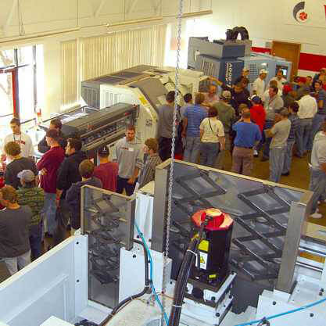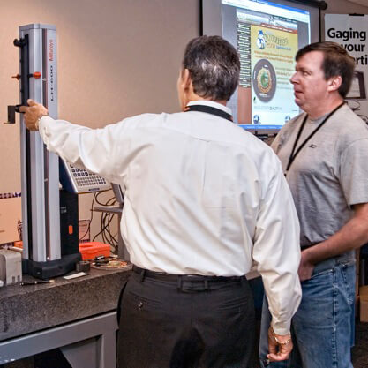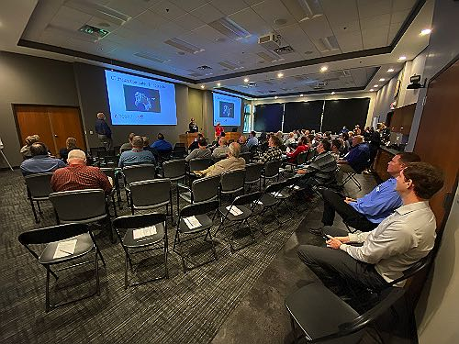

www.productivity.com/oktoberfest-tool-show

**Productivity Inc**  
15150 25th Ave. N.  
Plymouth, MN 55447

