Minnesota State University, Mankato
Department of Mechanical and Civil Engineering

Using an Interactive Approach to Teach Connections in a Steel Design Class
User’s Guide

by

Karen C. Chou, Ph.D., P.E. and Saeed Moaveni, Ph.D., P.E.

The intent of the Interactive Steel Connection Sculpture is to enhance the students’ learning in steel connection design as well as to show the field applications of these connections. This software is intended to be dynamics. We will continue to add field examples to the presentation. Any contribution to the data base is greatly appreciated. Following is the guideline for exploring the sculpture:

- A typical elevation view of the sculpture is shown in Figure 1.
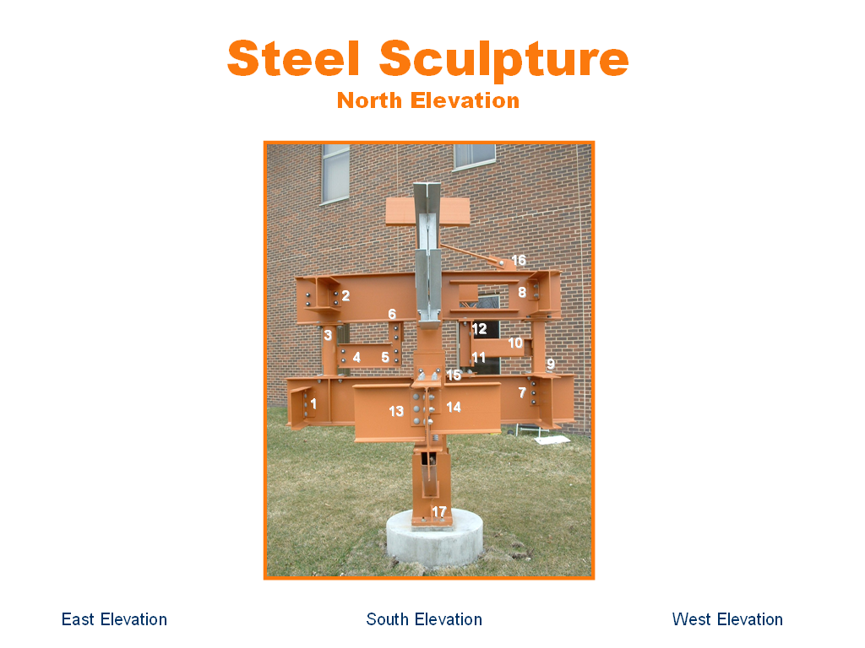
Figure 1 North elevation view
hyperlink to connection 1
hyperlink to west elevation view

  - The other elevation views are hyperlinked by the button at the bottom of the slide. In Figure 1, they are “East Elevation”, “South Elevation”, and “West Elevation” since the North Elevation is shown.
  - The numbers on the sculpture image represent the connection number. Each of the connection is hyperlink by clicking at the number shown.
  - As an example, click on “1”, you will see the close-up view of connection 1 as shown in Figure 2.
- Figure 2 shown the close-up view of connection 1 and the limit states of this connection.
  - You can hyperlink back to the elevation view, to a set of sample calculations in pdf, or to field examples by clicking on the appropriate phrase at the bottom of the slide.
  - To return to the connection slide, use the “back” button from the web tool bar.
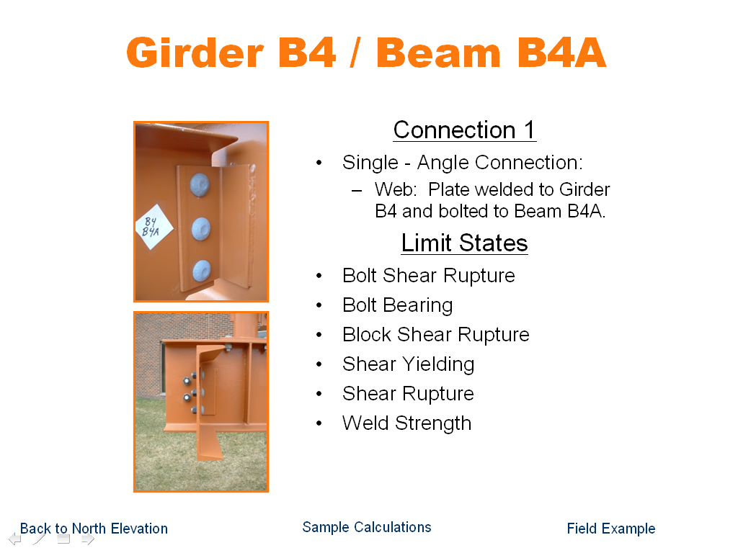
Click here to go back to elevation view
Click here to go back to elevation view
Click here to go back to elevation view
Figure 2 Close-up view of connection 1

- Figure 3 shows a field example of connection 1. You can click on the “more” to see additional field examples, if there is more than one field example available for the connection.

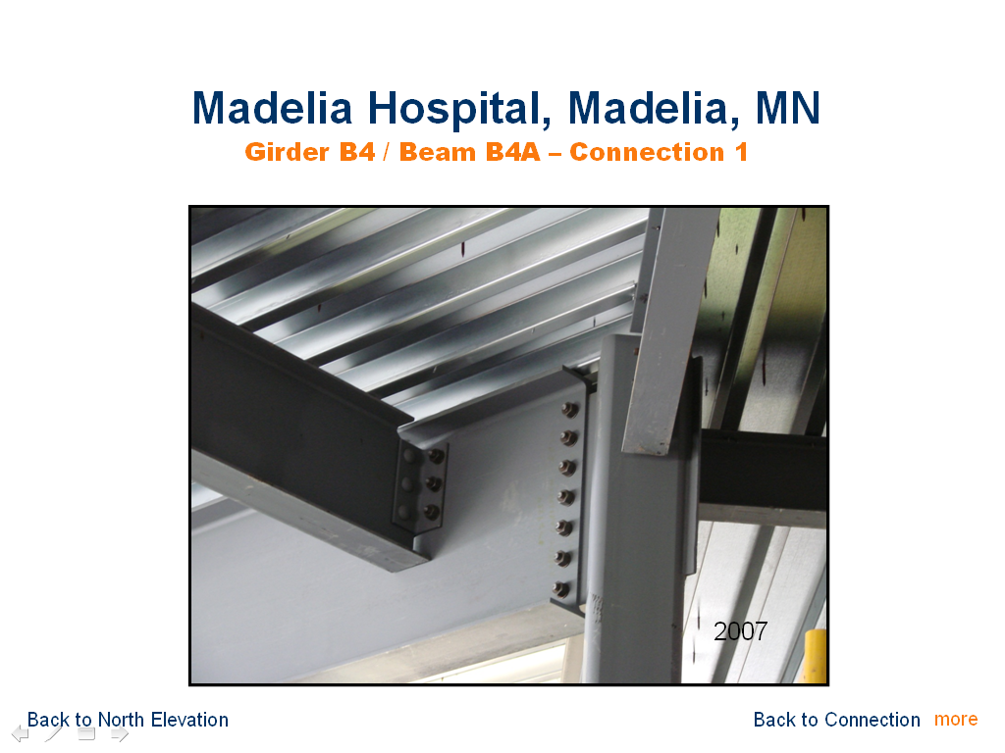
Click here for more field examples
Figure 3 A field example of connection 1

We hope you will enjoy this interactive sculpture. Please send comments, suggestions, and field examples to Dr. Karen Chou via e-mail at karen.chou@mnsu.edu. Thank you very much for your time.
Figure 1 Close-up view of connection 1

