Technical Memorandum
To: Dr. Saeed Moaveni
CC: Dr. Patrick Tebbe, Dr. Schwartzkopf
From: Matthew Simones, Arbin Timilsina
Date: 8/6/2008
Re: Site Descriptions

The Breck School

The Breck School has four SolarWalls installed on the south wall of their gymnasium. The walls were installed next to one another and take up most of the useful area on this south wall. The channels of the wall panels run horizontally and have a slotted, not a hole, design. Each wall is connected to its own fan unit on the inside of the gymnasium. The air from each SolarWall is extracted at four points and combined in a manifold before entering the fan unit. Each fan unit is gas fired and independent from one another. The fan unit on the east end is run hotter during the winter for gymnasts who are not as active as the basketball players using the remaining space. There is no fresh air bypass for the fan units to use, which can lead to cooling issues and overheating of the space. The management system in place currently measures the temperature of the air leaving the fan unit, the air at the end of the duct, and the room temperature. The fans operate at a constant speed so a constant flow rate could be assumed.
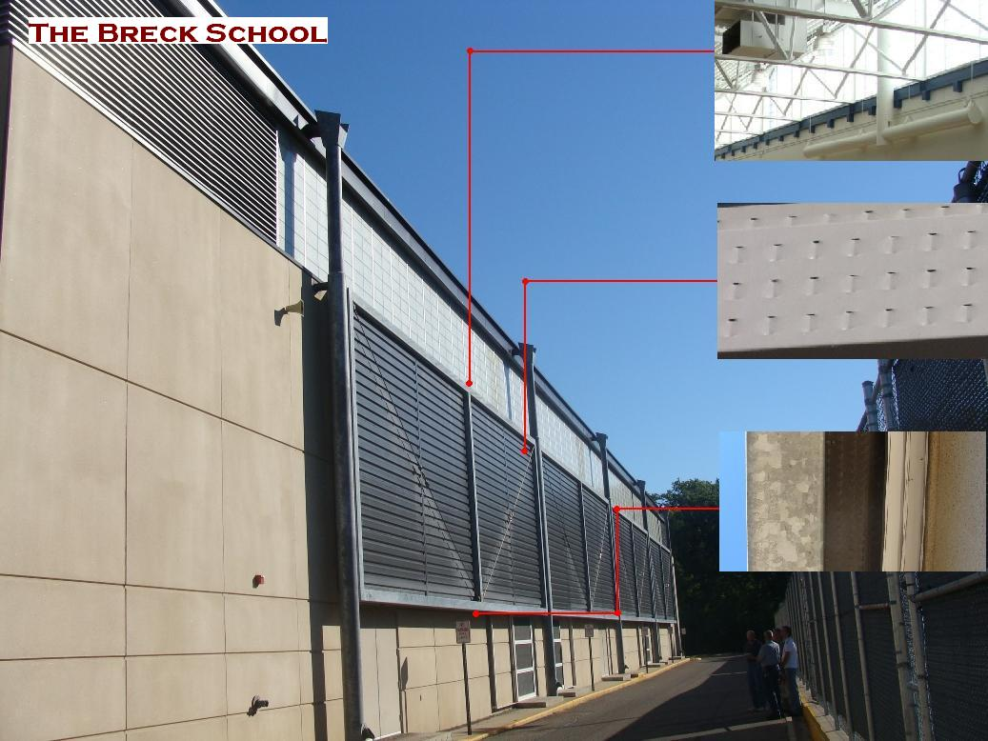
Neglecting conduction effects through the building wall and a constant flow rate from each fan, the minimum requirements for data logging would include measuring the air temperature before entering the fan unit, the ambient air temperature, solar irradiance, and possibly humidity to correct for air density. Other considerations would be collector surface temperature and wind speed, depending on the analysis. It is not certain what other parameters can be obtained from the management system.

Aveda headquarters

The solar wall installation at Aveda is located on a tier of the roof above the manufacturing facility. The air from the SolarWall is ducted to a single fan unit directly behind it on the inside. The channels of the SolarWall run vertically and have a hole design. The SolarWall has an offset section following the architecture of the wall on which it is mounted. From the inside, it appears that there are two air outlets, one for each section of the SolarWall. Air from the collector is extracted from the center of the east section, and pulled from the side at the offset from the other. The fan unit also has a fresh air bypass located on top of the tier when air from the SolarWall is too high. Aveda has construction plans from Conserval in possession, but any copies need to be authorized by Aveda. The management system in place measures temperatures from the SolarWall and from the Bypass. The fan used is also rated for a constant speed, so flow rates could be estimated.
Neglecting conduction effects, it seems that the management system could provide most of the measurements. It is not known if Aveda is willing to use the system to collect data. Because of the level of security in this building it would be best to use a wireless transmitter to send all of the recorded data. If the management system could be utilized, then ambient temperature and humidity, solar irradiance would need to be measured. Other parameters might include collector surface temperature, and wind speed.
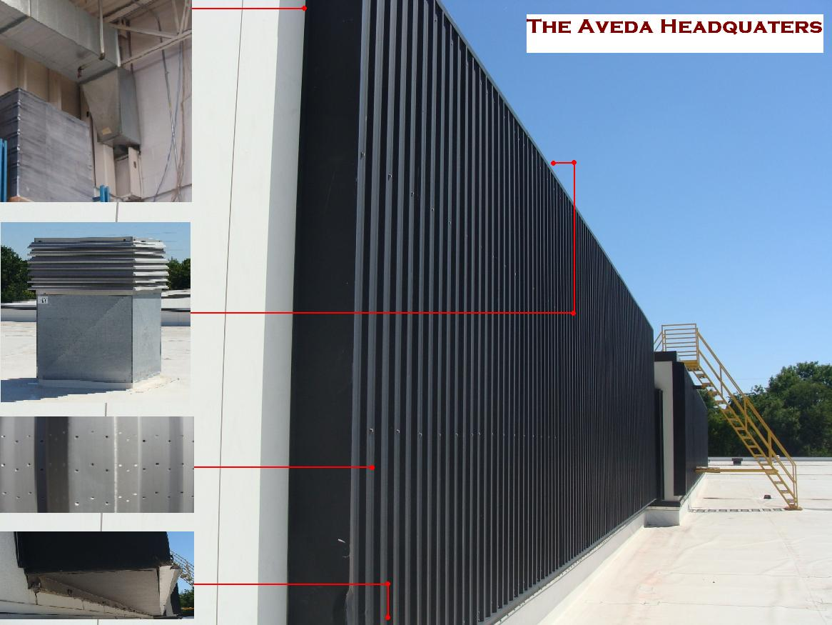

Interdistrict Downtown School (IIDS)

The building itself consists of five floors with a parking ramp located underneath the building. The SolarWall installation is located on the top Tier of the building, mounted on the outside wall of the mechanical floor (5th floor). All of the fresh air for the building enters along the same wall, so several air vents break up the SolarWall along its length. Air from the SolarWall is directed into a duct which runs along the top of the wall. A damper is installed near the center of the duct where air from both sides of the wall combines before being directed to the economizer and finally to the heat recovery unit #2, which feed the 3rd and 4th floors of the building. The economizer draws air directly from the outside and is fitted with a damper. The dampers on the SolarWall and economizer are controlled by the management software and can blend the two as necessary. However, the operation of the SolarWall and economizer doors is currently in question because the SolarWall damper was open during the visit in the cooling season. The facilities manager also claimed that the economizer air is not always as cold as expected, possibly due to the air blending with that from the SolarWall. This location uses variable frequency drives (VFD), so flow rates will need to be determined. Flow rates will be difficult to measure because the air from the SolarWall converges from two ducts at the damper and immediately enters the mixing chamber at the heat recovery unit. Architectural and design plans may be available from IDDS, otherwise the Cuningham Group designed the architecture for this building and Michaud Cooley Erickson designed the HVAC system.
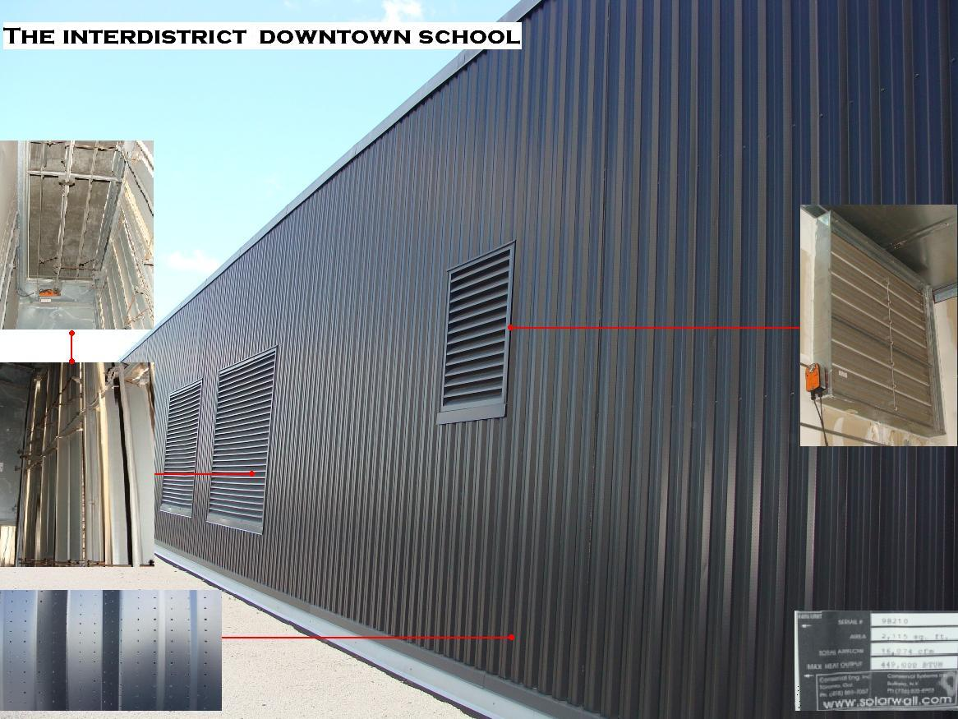
Neglecting the conduction effects at this location, the management system could provide an outlet air temperature from the SolarWall and percentages for the VFD’s. Measurements needed include solar irradiance, ambient air temperature, and humidity. Additional measurements would include collector surface temperature and wind speed. Flow rates will also need to be determined and/or monitored since they are variable.

