THOROUGH ANALYSIS OF A TWO-STROKE CYCLE ENGINE VERSUS A FOUR-STROKE CYCLE ENGINE:
Minnesota State University, Mankato’s entry for the SAE Clean Snowmobile Challenge 2002
Tim Anderson, Mark Brandl, Ryan Erickson, Jeff Gillen, Cory Ranweiler, Jan Smith, Neil Swanson, Daniel Utes
Senior Team Members
Wendy Bock, Nick Bredemus, Dan Dobesh, Tom Hanson, John Kellander, Andy Laconic, Jeremy Losinski, Joe Mohrfeld, Matt Poylio, Matt Sandlin, Jason Wilkie
Supporting Team Members

Dr. Bruce Jones and Kirk Ready
Faculty Advisors

ABSTRACT
This paper discusses the Minnesota State University, Mankato Automotive Engineering Technology program’s entry to the 2002 Clean Snowmobile Challenge. Included in this report are the snowmobile model chosen for modification, engine choice, modifications applied, methods used, and modification results affecting performance, emission control, noise reduction, production cost, durability, fuel efficiency, safety, and rider comfort.
The MSU Mavericks devoted their main focus for the Clean Snowmobile Challenge 2002 to the comparison of a two-stroke cycle engine to a four-stroke cycle engine. A direct fuel-injected two-stroke cycle engine and a turbo-charged four-stroke cycle engine were selected and were subjected to extensive modifications and testing procedures. Each engine was tested for emissions, noise, and performance; these test results were used to determine the final entry design.
INTRODUCTION
The Society of Automotive Engineers (SAE) developed the Clean Snowmobile Challenge in response to the increasing concern of snowmobile use in our national parks. The noise and exhaust emission levels of snowmobiles greatly concerns environmentalists, as these emissions threatened the health of area wildlife and the environment in which they live. In an attempt to allow snowmobile users continued enjoyment of these national treasures while lowering the environmental impact of snowmobile use, SAE challenges engineering and engineering technology students to reduce the noise and chemical emissions of a snowmobile without sacrificing performance or commercial feasibility. These modified snowmobiles are then compared on the basis of performance in competitive trials and emissions tests.
With a central focus of lowering noise and exhaust emissions while maintaining performance, the Clean Snowmobile Challenge allows entrants to select any snowmobile platform, and to choose from a range of engine styles and sizes. This wide choice of alternatives allows team members to fully employ their knowledge, talents, and creativity to develop a versatile entry and a winning machine. It also opens the field to higher competition.
Minnesota State University, Mankato (MSU) was one of sixteen colleges and universities approved by SAE for the 2002 competition, with the entrants selected by evaluation of each school’s submitted design proposal. The competition was conducted March 23-31, at Flag Ranch, just outside Yellowstone National Park, Grand Teton National Park, and Snow King Resort, in Jackson Hole, Wyoming.
Minnesota State University, Mankato is one of seven state universities in the Minnesota State Colleges and Universities (MnSCU) system. Located in south-central Minnesota, it is attended by over 13,000 students. MSU offers an Automotive Engineering Technology (AET) program as a four-year Baccalaureate degree through the College of Science, Engineering, and Technology. Automotive Engineering Technology is accredited by the Technology Accreditation Commission of the Accreditation Board for Engineering and Technology (TAC-ABET). The MSU AET program consists of 160 students pursuing a degree in the field, with 33 of those students scheduled for graduation during the 2002-2003 academic year.
Each student candidate for the AET Baccalaureate degree must complete a comprehensive senior design project; eight senior students selected the Clean Snowmobile Challenge 2002 to satisfy this requirement. Along with these eight seniors, eleven underclass joined together to form the MSU Mavericks Clean Snowmobile Team, Figure 1. Study of the MSU 2001 entry to the Clean Snowmobile Challenge inspired new ideas for improvements and modifications; with the acceptance of the MSU design proposal, those ideas grew. With open communication between team members, and strict compliance with SAE rules and regulations, the Mavericks strove to maintain the delicate balance between the goals of performance, emissions control, and cost effectiveness in their design decisions.
Figure 1 MSU Mavericks Team 2002
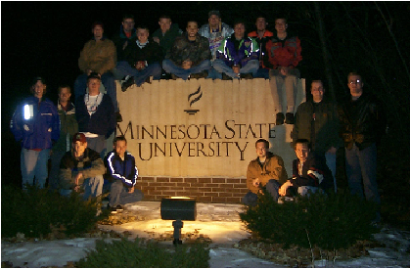
In an effort to design the ultimate clean snowmobile for competition, selection of an appropriate power plant was a major decision. The two most viable solutions based on current technology were judged to be the two-stroke and four-stroke cycle engines. Each engine type has inherent advantages and disadvantages when measured against the competition criteria. As a result of this initial comparison, the team decided to conduct a head-to-head comparison of the two engine types to determine which configuration would be used in the competition snowmobile.
To accomplish the building and testing of the two-stroke and four-stroke cycle systems, and the completion of all other systems necessary for two complete snowmobiles, the organization was divided into four separate teams: chassis, exhaust, two-stroke cycle, and four-stroke cycle. Members selected a particular team based on their interest and area of expertise. The chassis team focused on platform selection, design improvements, drive train modifications, suspension upgrades, and appearance of the finished snowmobile. The exhaust group concentrated on catalyst selection, muffler design, and pipe layout. The two-stroke cycle team devoted their efforts to the development of the direct fuel injection system; this process included a thorough investigation of fuel injectors, computer-management systems, and cylinder head designs, with subsequent modifications tested for improved emissions and performance. The four-stroke cycle engine team’s focus was the improvement of the engine’s performance to a level comparative to the two-stroke cycle engine while maintaining low emissions. This group implemented fuel injection and a turbo-charging system to the four-stroke engine, and then tested the results of the modifications.
Communication between the four teams was vital. Each specialized group brought its findings and conclusions to weekly meetings of the entire MSU Mavericks team. During these meetings, team members suggested further improvements, and the entire team determined the next week’s course of action for each individual group. These meetings also served as a panel discussion for technical questions, scheduling, deadlines, and documentation. It was through this process of open communication that the final choices for everything from fund-raising to chassis and engine selection were determined and successful designs were realized in a timely manner.
Engine Selection
Cost, emissions, fuel economy, noise, and performance were all factors that determined the engines selected. Relative importance of each factor was determined according to the percentage of total points awarded to each event in the Clean Snowmobile Challenge.
Two-Stroke cycle engine
Aside from the amount of hydrocarbon emissions, a two-stroke cycle engine will outperform a four-stroke engine in all areas, including “specific power, specific bulk, specific weight, maneuverability, manufacturing cost, ease of maintenance, durability, fuel consumption, or CO and NO emissions” [1]. The statement of superiority in the areas of fuel consumption and durability may be questioned. However, Blair went on to say, “small capacity four-stroke cycle engines are not particularly thermally efficient. The reason is that friction losses of the valve gear and oil pump begin to assume considerable proportions as cylinder size is reduced, and this significantly deteriorates the mechanical efficiency of the engine” (483-4). In the area of durability, fewer moving parts in the engine contributed to an increase in durability.
SAE rules of competition state that the students’ task is “re-designing a snowmobile to improve its emissions and noise while maintaining performance characteristics” (SAE Clean Snowmobile Challenge 2002 rules for competition). Based on these stipulations, the “re-designing” of the standard snowmobile engine must be addressed. With the aforementioned statements and the shortcomings of a four-stroke cycle engine as described by Gordon Blair, the two-stroke cycle snowmobile engine was a good choice to lower emissions and noise without detracting from performance.
A Polaris 500-cc variable exhaust twin cylinder two-stroke cycle engine was selected as the baseline engine for several reasons. This engine has exhaust valves, uses liquid cooling, is compact and lightweight, and the engine and parts were readily available.
Performance
According to Stone [2], when comparing two-stroke and four-stroke cycle engine torque or power per unit volume, two-stroke cycle engines rate approximately 17% higher (336). Maintaining performance meant starting with an engine that was as powerful as a typical trail snowmobile, such as the baseline snowmobile used at the Clean Snowmobile Challenge 2001. According to CSC 2001 results, the baseline snowmobile produced 9.73 kW (13.05 hp) @ 7200 rpm, measured at the track. The two-stroke cycle engine MSU selected for CSC 2002 produced 34.84 kW (46.72 hp) @ 7800 rpm at the track during CSC 2001, thus providing a good foundation for performance.
Emission Control
Heywood [3] states, “because there is a substantial (of order 20%) loss of fresh air during the scavenging process due to short-circuiting and mixing with exhausting burned gases, direct injection of fuel into the cylinder is especially attractive with the two-stroke cycle” (6), and goes on to say, “the direct loss of fuel may be reduced with charge stratification, and completely eliminated when operating with a direct-fuel-injection system” (157). A direct-fuel-injection system was employed in an attempt to overcome problems associated with two-stroke cycle engine emissions and fuel efficiency.
The original engine was equipped with variable exhaust valves. These valves can change port timing, port area, and effective compression ratio based on cylinder pressure, which allows for better fuel efficiency at low engine speed while allowing for high engine speed power. With the use of variable exhaust timing, the engine can take advantage of active radical combustion at light load and low engine speeds to decrease the scavenging of unburned hydrocarbons [1]. This increased trapping of pressure due to earlier exhaust port closure at low engine speed and light load results in a more complete burn of the air/fuel mixture, thus lowering unburned hydrocarbon emissions [1].
Durability
Past Clean Snowmobile Challenge competition experience has demonstrated the importance of a durable snowmobile. The durability of the machine is crucial both in event competition and its eventual success in consumer markets. Durability was retained in this engine by beginning with a proven design and improving the critical areas to compete in the competition.
The two-stroke cycle engine has been improved over the years in an effort to increase durability and longevity. Many of the past durability issues have been a result of incorrect air/fuel mixtures; this problem can be significantly reduced through the use of fuel injection that adjusts the air/fuel mixture according to temperature and altitude conditions.
Direct fuel injection is a proven technology and has been successfully incorporated into the two-stroke cycle engine designs of several marine OEMs. Cameron [4] compared several variations of DFI technologies used and found no significant injector durability problems.
Another durability issue focuses on the use of solid-state electronics. The durability of solid-state electronics has been proven over time in the automotive industry; by utilizing electronic devices with no moving parts, there is no chance of mechanical failure.
Any electronically controlled engine will need sensors to operate. As the stock engine was equipped with two sensors, only three additional sensors were necessary. By using fewer sensors for input, sensor failure is less likely to occur.
Fuel Efficiency
Two-stroke cycle engines typically create more power (17% more) than their four-stroke counterparts; thus, they must use more fuel. This increase in airflow and fuel flow can be partly contributed to the fact that two-stroke engines ingest air once per crankshaft revolution, while four-stroke engines ingest air once every other crankshaft revolution. However, the thermal efficiency of two-stroke engines is lower than that of four-stroke engines. This lower thermal efficiency, caused in part by scavenging losses, can be greatly reduced through the implementation of direct fuel injection.
Two-Stroke Cycle Engine Modifications
The two-stroke cycle engine--the conventional engine used in all snowmobiles--has been used in snowmobile production since the 1960s, and with good reason. The simple design produces a cost-effective production engine that is compact and lightweight, making it the ideal engine for a small recreational vehicle. With lower weight and twice the power strokes of a similar four-stroke cycle engine, the two-stroke cycle engine has a very good power-to-weight ratio.
The basic two-stroke engine began as a very simple design. Its evolution has shown many improvements in efficiency, including oil injection, liquid cooling, electronic fuel injection, and variable exhaust port timing. The next step for advancement of the two-stroke cycle engine was direct in-cylinder fuel injection.
The primary shortcomings of the two-stroke cycle engine design are in the area of HC and CO emissions. Figures 2-5 illustrate the improvements that can be made in these areas through the implementation of DFI.
Figure 2 Carbureted CO emissions
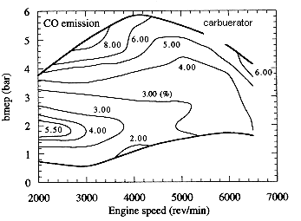
Figure 3 DFI CO emissions
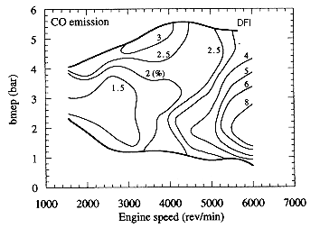
Figure 4 Carbureted HC emissions
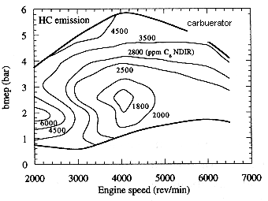

Figure 5 DFI HC emissions
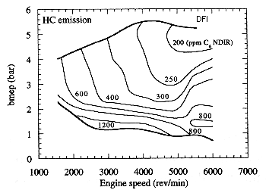
Electronic Control Unit
A MoTeC control unit was selected as the central controller for the engine. This fully programmable engine management system collects data from a number of operating conditions, and based on the input from the five sensors listed below, the system adjusts fuel-injection timing to maintain peak performance and efficiency throughout all operating ranges and environmental conditions.
- Coolant Temperature
- Intake Air Temperature
- Crankshaft Position
- Throttle Position
- Barometric Pressure

High-Pressure Direct Injection
A Siemens high-pressure direct-fuel-injection (HPDI) system comprised of a high-pressure pump, fuel injector driver, and two fuel injectors (one per cylinder) were chosen for this project. A high-voltage (100 volt) fuel injector driver controlled by the MoTeC triggers the fuel injectors. The injectors were calibrated to have the proper flow characteristics for this engine application. This calibrated injector fulfilled the flow demand of 14 grams/second permitting 78.30kW (105hp) @ 8100rpm. An injector having this flow produces a large cone angle (48º @ 15mm) with this type of fuel injector. Consequently, this design promotes better mixing of air and fuel, because the fuel is more evenly distributed throughout the combustion chamber.
Fuel Pump
A synchronous belt-driven three-piston radial fuel pump delivers 0.6 cc/revolution of fuel at 7584 kPa (1100 psi) to the fuel injectors. A secondary in-tank electric fuel pump supplies 155 liters per hour (40.9 gph) at 138 kPa (20 psi) to the high-pressure pump to eliminate fuel cavitation. A belt-drive assembly was constructed on the magneto side of the engine to house the belt-driven fuel pump. The assembly consists of an inner plate, an outer plate, an extended crankshaft with attached drive gear, a fuel pump shaft with attached driven gear, and an idler arm belt tensioner assembly (Figure 6).
Figure 6 Fuel Pump Drive Assembly
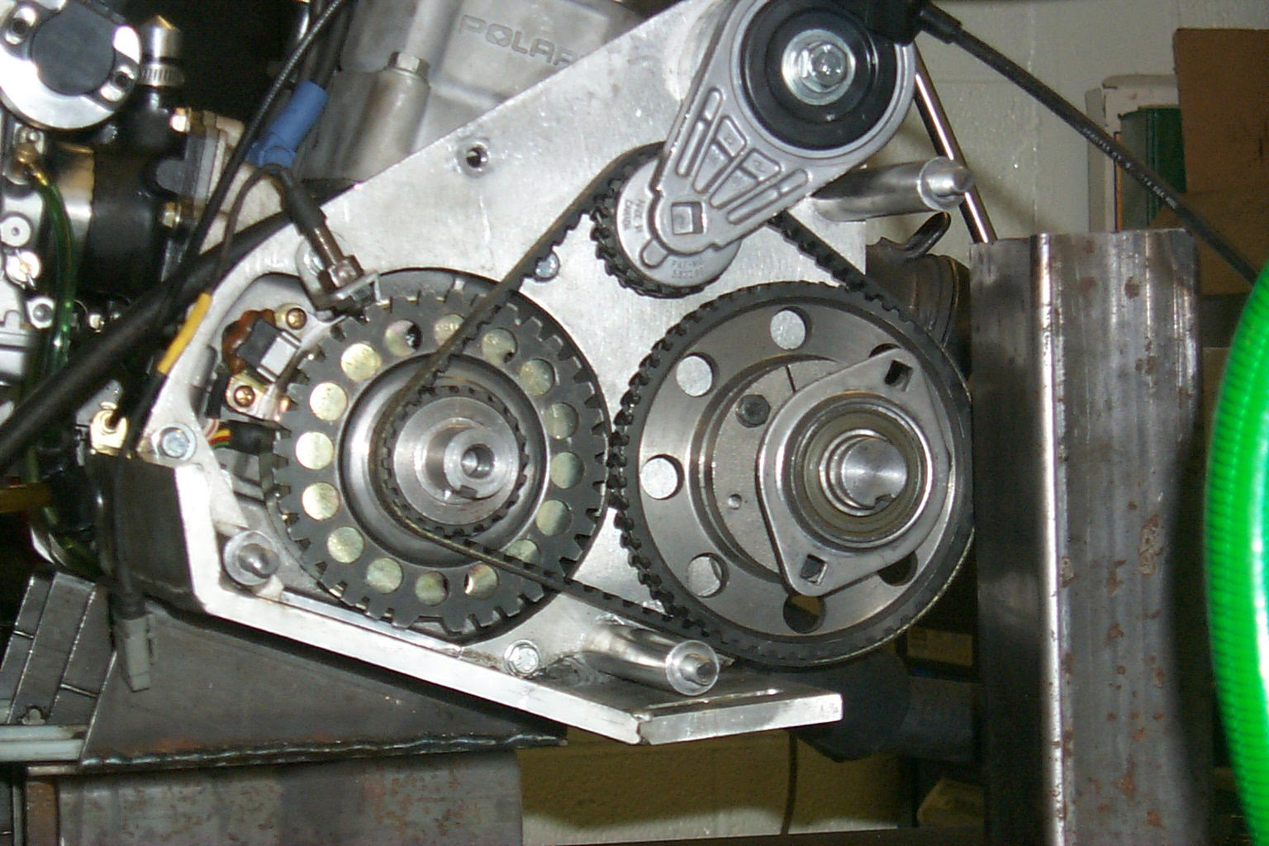
Charging
The stock system utilized a 280-watt stator with a regulator and a single diode rectifier, which takes advantage of only half the stator’s potential energy. In order to take full advantage of this potential, the stator wiring was reconfigured to use a multiple diode rectifier, which increased the output of the stator to meet the demands of the system.
Combustion Chamber
The considerations for cylinder head design taken into account were:
- Surface-to-Volume Ratio
- Combustion Control
- Thermal Loading
- Spark Plug Location
- Fuel Injector Location

Surface-to-Volume Ratio
High surface-to-volume ratios drastically increase HC emissions. This relationship eliminated a conical design from consideration. According to Jennings [5], “the best combustion chamber shape--taken strictly from the standpoint of surface/volume ratio--would be a simple spherical segment sweeping in a continuous arc from one side of the cylinder bore to the opposite side” (41). Also, in order to run a trapped compression ratio of higher than 6.5:1, a combustion control element is needed in the form of a squish band (41).
Combustion Control
The combustion chamber was designed for maximum squish velocity to aid in the mixing of the fuel and fresh incoming air. “End gases in the squish band do not burn with the main charge, and are only partly consumed as the piston moves away from top dead center and releases them from their cooling contact with the surrounding metal.” Those end gases contribute heavily to unburned hydrocarbon emissions [5]. By reducing squish clearance, the end gas volume is minimized, thus resulting in more horsepower and fewer unburned hydrocarbons. In an attempt to increase squish velocities without increasing the squish area, the combustion chamber dome was offset to the intake side. This also reduced thermal loads to the piston on the exhaust side, allowing for higher compression ratios [5].
Spark Plug Location
The best spark plug location is in the center of the combustion chamber [5]. Centralizing the spark plug can also reduce the need for advancing ignition timing, because the flame front has less distance to travel. The spark plug was angled at 30° from vertical and rotated 30° from the axis that runs through the intake boost port and the exhaust port. By angling the spark plug down 30° from vertical, the plug electrode was moved closer to the center of the combustion chamber. Although the plug is at the periphery of the spherical chamber, using a knob in the chamber to get the plug closer to the center would upset the surface-to-volume ratio. Also, by placing the plug too close to the piston, concentrated overheating can occur in that region of the piston surface, which would necessitate lower compression ratios [5]. The side-offset rotation was implemented for the reason of head bolt clearance, causing restricted space for the spark plug. Because of this limitation, the spark plug size was reduced from 14 mm to 10 mm.
Fuel Injector Location
As “liquid fuel wall wetting on all surfaces of the combustion chamber is detrimental to HC emissions” [6] the fuel injector was placed in a central location to help eliminate cylinder wall wetting. Part of the fuel spray is injected into the direction of the incoming intake air to help obtain a homogenous charge.
Combustion Chamber Choice
Figures 7 and 8 show the two combustion chambers designed for the direct injection system based on the previously mentioned thoughts. The design of Figure 8 was abandoned due to the fuel spray being deposited on the combustion chamber and cylinder wall, causing hard starting and spark plug wet fouling.
The combustion chamber shown in Figure 8 was designed and built similar to the previously described chamber with the exception that the fuel injector and plug were oriented differently. In this design, the spark plug was moved into the axis that runs through the intake boost port and the exhaust port, and the fuel injector was angled to spray fuel over the spark plug in an attempt to create a rich, stratified charge in the spark plug gap, allowing the engine to run in an extremely lean overall condition at light loads. This layout also allowed for later injection timing, reducing the scavenging losses, thus lowering HC emissions and increasing fuel economy.
Figure 7 Combustion Chamber Utilized
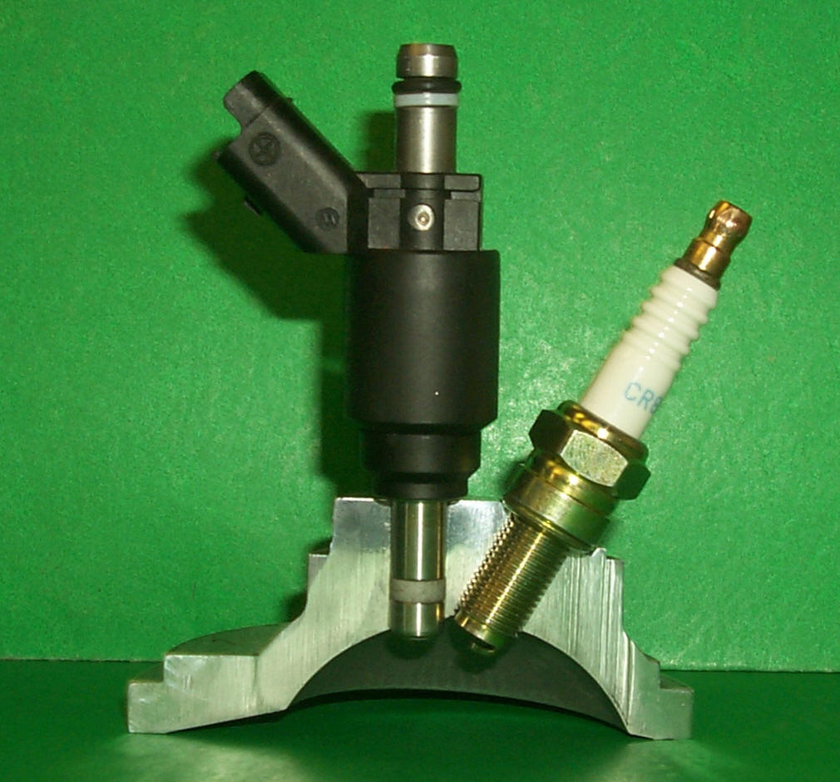

Figure 8 Alternate Combustion Chamber
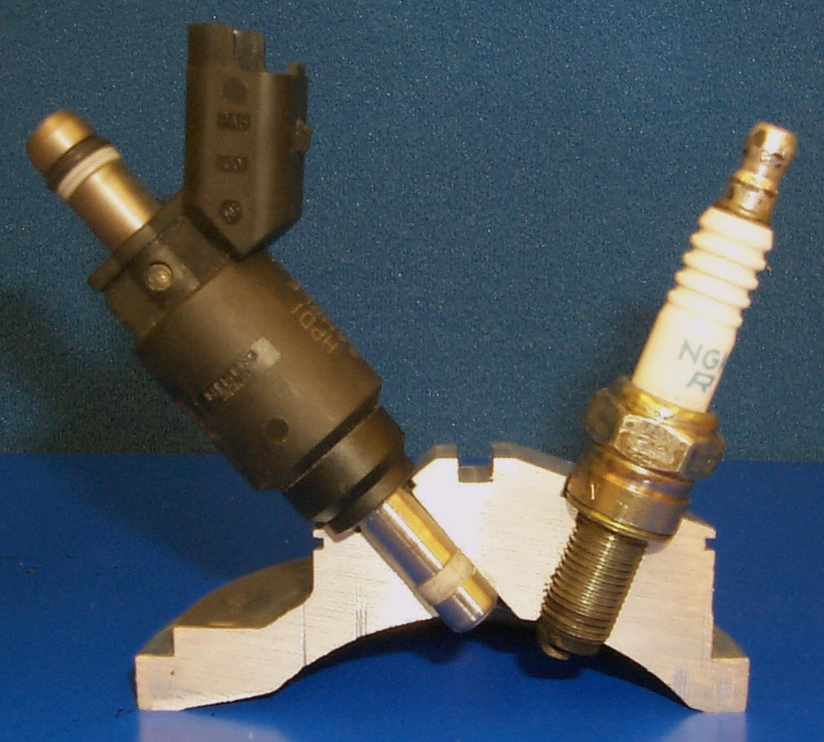

Table 1 Two-Stroke Engine Specifications
 | Stock Engine | Modified Engine
Compression Ratio (Trapped) | 6.07:1 | 6.57:1
Compression Ratio (Full-Stroke) | 10.91:1 | 13.44:1
Bore | 70.5 mm  (2.776 in) | 70.5 mm  (2.776 in)
Stroke | 64 mm  (2.520in) | 64 mm  (2.520in)
Head Volume (Uninstalled) | 26.5 cc | 24.4 cc
Head Volume (Installed) | 25.2 cc | 23.7 cc
Squish Clearance | 1.65 mm | 1.27 mm
Squish Area Ratio | 42.8% | 39.8%
Squish Velocity | 17.2 m/s  @ 12^{O} BTDC | 34.2 m/s  @ 9^{O} BTDC
Peak Horsepower RPM | 7700 | 7800
Cranking Pressure | 133 psi | 165 psi
Exhaust Port Open | 77^{O} A&B TDC | 77^{O} A&B TDC
Octane Recommended  (R+M)/2 | 85 | 97
Fuel Delivery System | 2 Mikuni TM  38 mm flat slide carburetors | MoTeC Controlled Siemens HPDI
Charging System | 280 watts | 280 watts
Spark Plug/Gap | Champion RN57YC/ 0.028” | NGK R CR9E/0.035”
Power SAE | 67.86kW  (97hp) | 59.66kW  (80hp)

Production Cost
Based on the cost assessment outlined in the technology implementation cost analysis (TICA) spreadsheet, the cost of implementing the technology utilized in the two-stroke cycle engine was $868.50. Three factors were identified with the potential to offset the increased purchase price of the snowmobile for outfitters. Due to the increased fuel efficiency of the HPDI system, the cost of the added technology is recovered over the life of the snowmobile.
The first cost benefit is from a decrease in labor costs. The fuel injection system incorporates intake air temperature and barometric pressure sensors, so that fuel-system calibration is automatically adjusted to meet the needs of a wide variety of temperature and elevation conditions. Fuel-mixture jets in a carbureted snowmobile, on the other hand, must be changed manually as these conditions change.
The ability of the computer-controlled system to maintain an ideal air/fuel mixture affects the durability and life span of several components in the engine. Spark plugs are less likely to be fouled by an overly rich air/fuel mixture. An ideal mixture also reduces the potential carbon buildup in the combustion chamber and exhaust valve, which periodically requires cleaning, translating to labor costs. Also, the ideal air/fuel mixture can avoid engine failure due to detonation and excessive head buildup on internal components. Quantifying these cost benefits can be difficult, but their impact cannot be ignored when exploring options to the current technology.
The final cost benefit can be quantified more easily. The decreased short-circuiting of the incoming air/fuel mixture caused by direct fuel injection not only reduces emissions, but it also decreases brake-specific fuel consumption. This in turn yields a proportional increase in fuel efficiency, which translates into fuel cost savings.
Four-Stroke Cycle engine
In the search for an engine that produces fewer emissions, the four-stroke cycle engine has become the next step for many applications ranging from lawnmowers to off-road motorcycles. This trend is slowly making its way to the snowmobile, despite the two-stroke cycle engine’s desirable power-to-weight ratio.
“For a given size engine operating at a particular speed, the two-stroke engine will be more powerful than a four-stroke engine since the two-stroke engine has twice as many power strokes per unit time” [2]. The inherent problem with the traditional two-stroke cycle engine is that its efficiency is lower than that of the four-stroke cycle engine, and it produces much more emissions. Since the intake and exhaust occur on the same stroke in a two-stroke cycle engine, some of the raw fuel escapes through the exhaust, producing poor emissions. The four-stroke cycle engine overcomes this obstacle with intake and exhaust on separate strokes of the engine. Very little overlap of intake and exhaust allows the engine to run more efficiently and produce fewer emissions.
The four-stroke operating cycle consists of four strokes of the piston. First, the intake stroke draws fresh air and fuel through the opened intake valve into the combustion chamber as the piston moves downward. Second, during the compression stroke, both the intake and exhaust valves are closed as the piston moves upward to compress the air/fuel charge. Spark is introduced from near the end of the second stroke to the start of the third stroke, which is the power stroke. During the power stroke, both valves are again closed and combustion occurs, forcing the piston downward. The final stroke is the exhaust stroke; as the piston moves upward with the exhaust valve open, the remaining gasses are expelled from the combustion chamber [2].
To take full advantage of the four-stroke cycle, the engine has many more parts and a heavier weight than a conventional two-stroke cycle engine. In addition to the crankshaft, connecting rod, and piston, the four-stroke cycle engine utilizes a camshaft, lifters, and valves to control the air/fuel flow in and out of the engine. A large flywheel is also used, which acts as a counter-weight to keep the engine spinning during the three strokes between power strokes.
The four-stroke cycle engine has a smaller power-to-weight ratio to the equivalent two-stroke cycle engine, but runs more efficiently and produces fewer emissions. Additionally, several modifications can be made to the four-stroke cycle to increase the power-to-weight ratio of the engine, including turbo-charging and super-charging the engine. Both methods push additional air into the combustion chamber, which increases volumetric efficiency. This additional air, combined with extra fuel, results in greater horsepower. Using electronic ignition control and fuel injection instead of carburetion can also help increase the power produced by the engine by allowing greater control of the ignition and fuel maps.
Four-Stroke Cycle Engine Modifications
A Polaris 500-cc four-stroke single cylinder engine was selected for base testing. This engine is used in the Polaris Sportsman H.O. all-terrain vehicle (ATV). This engine was chosen for two reasons: First, the engine is liquid cooled, which allows operation at a constant temperature. This improves the accuracy of tuning, resulting in reduced emissions. Second, the engine uses two intake and two exhaust valves for its single cylinder, which allows for a better combustion process and, again, cleaner emissions.
The engine and after-market parts were readily available through many locations, making this engine a practical choice for introduction into the snowmobile. The ATV also uses the same clutching as a snowmobile, which made it easy to adapt to the standard snowmobile drivetrain. Finally, ease of adaptation of the turbo-charger and electronically controlled fuel-injection system made the engine ideal for modification.
Table 2 Four-Stroke Engine Specifications
 | Stock Engine | Modified Engine
Displacement | 499 cc | 499 cc
Bore | 92 mm  (3.6248 in) | 92 mm  (3.6248 in)
Stroke | 75 mm  (2.955 in) | 75 mm  (2.955 in)
Valve Lash | 0.006 in @ TDC on compression | 0.006 in @ TDC on compression
Compression Ratio | 10/2 Full Stroke | 10/2 Full Stroke
Cooling | Liquid Cooled | Liquid Cooled
Lubrication Type | Dry Sump | Dry Sump
Operating RPM | 6500 RPM | 6700 RPM
Peak Horsepower RPM | 5900 RPM | 6800 RPM
Power SAE | 31.32kW (42hp) | 48.47kW (65hp)

Electronic Control Unit
A computer control system was used to precisely control the fuel and ignition systems to improve performance and minimize emissions. The computer compensates for any changes in temperature or altitude, allowing the engine to maintain maximum efficiency in all conditions.
A MoTeC engine-management system was chosen to control the fuel delivery and spark ignition. This fully programmable engine management system uses input from six different sensors, listed below, to determine the operating conditions of the engine. Based on the readings from these sensors, the MoTeC can be programmed to inject the proper amount of fuel and fire the spark plug at the desired time for optimal performance and emissions.
- Coolant Temperature
- Intake Air Temperature
- Crankshaft Position
- Camshaft Position
- Throttle Position
- Barometric Pressure

Fuel-Injection System
The factory carburetor was replaced with a throttle body fuel-injection system to allow better control of the fuel entering the combustion chamber. The throttle body directly replaces the carburetor, requiring little modification. The small automotive-style throttle body utilizes a Bosch fuel injector rated at 454 grams/hr (42 lbs./hr), with a cone angle of 15°, operating at 241kPa.
Using feedback from the engine sensors, precise control of the air/fuel mixture is obtained. This greatly reduces the amount of unburned hydrocarbons and carbon monoxide produced by the engine.
Turbo-Charger
A turbo-charger is used to increase the power-to-weight ratio of the four-stroke cycle engine. A turbo-charger operates by routing the exhaust gases from the engine through a turbine, which in turn spins a second turbine, forcing air into the engine’s intake, effectively increasing the volumetric efficiency. The increased air forced into the combustion chamber, mixed with the proper amount of fuel, causes larger combustion pressure and a greater power stroke. The turbo-charger allows a smaller, lighter four-stroke cycle engine to be used, while maintaining the power of a larger, heavier four-stroke cycle engine.
A type of turbo-charger called the Aerocharger® was installed on the four-stroke cycle engine. The Aerocharger® is designed for small engine applications up to 1000 cc and is self-contained, needing no oil from the engine for lubrication. The Aerocharger® uses the same operating principles as the turbo-charger, using a turbine driven by exhaust gases to compress air for the intake, but with one difference: the Aerocharger® uses variable vanes instead of a waste gate to control the amount of boost. The Aerocharger® was set to approximately a 69 kPa boost for this engine configuration.
The variable vanes direct the exhaust gases, maximizing the flow of exhaust into the turbine, which allows the Aerocharger® to gain speed faster. This reduces the turbo lag, the amount of time needed for pressure to build up in the intake, a common problem with turbo-charged engines. See Figure 9 for a comparison of the Aerocharger® to other methods of increasing intake pressure.
Figure 9 Comparison of Manifold Pressures
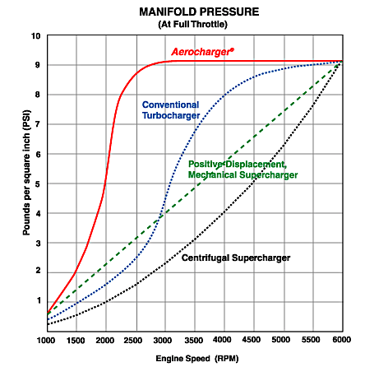
Camshaft Design

The third modification to the four-stroke cycle engine was the design of a new camshaft. To take full advantage of the turbo-charging system, it was decided that a new camshaft would be needed to eliminate much of the overlap between intake and exhaust lobes. A smaller duration of the valves could be used, while at the same time a sufficient volume of air would be delivered to the combustion chamber, helping to eliminate some of the intake and exhaust valve overlap. Several blank camshafts were located and sent to Competition Cams, a camshaft-grinding facility.
To begin the design of the camshaft, the stock camshaft was profiled using Cam Pro Plus. The camshaft measurements were recorded at 0.006 inches to determine overlap, duration, and valve separation angles as seen in Table 3.

Table 3 Camshaft Specifications

 | Stock Cam | Comp Cams
Intake max lift | 0.191 in | 0.191 in
Exhaust max lift | 0.191 in | 0.191 in
Overlap | 248° | 191.5°
Duration | 300° | 246°
Lobe Separation Angle | 70.8° | 70.0
By decreasing the valve overlap and increasing the valve separation angle, less of the fresh air and fuel mixture was allowed to escape through the exhaust. This was made possible by the turbo-charging system, which continues to supply the extra air needed into the combustion chamber without requiring an extended time with the valves open, decreasing the duration and the overlap.

The engine cylinder head is a four valve per cylinder configuration, with two intakes and two exhaust valves. This configuration allows air to flow more freely through the cylinder head. The cylinder head was mounted on a Super Flow SF300 flow bench to determine the airflow through the head. The flow measurements were recorded at several valve lifts and with several configurations of the intake system. Table 4 shows the flow data of the head and a radius inlet guide.

Table 4 Head Flow Data

Valve Lift | Exhaust Flow | Intake Flow
0.05 in | 27 CFM | 31 CFM
0.15 in | 80 CFM | 97 CFM
0.25 in | 121 CFM | 157 CFM
0.33 in | 135 CFM | 183 CFM

The data collected was used to determine appropriate lift and overlap of the camshaft lobes to take full advantage of the approximate 10-psi turbo boost.

Ignition System
A Jacobs I.C.E. PAK ignition system was used to deliver the spark to the engine. This system was chosen for its compatibility with the MoTeC system and its ability to deliver a high-powered spark to the engine. The use of the Aerocharger® requires different ignition timing than that provided by the stock system. With the Aerocharger®, timing is not advanced as far as with stock timing, as the revolutions per minute of the engine area are increased (Figure 10).

Figure 10 Timing Curve with Jacobs Ignition
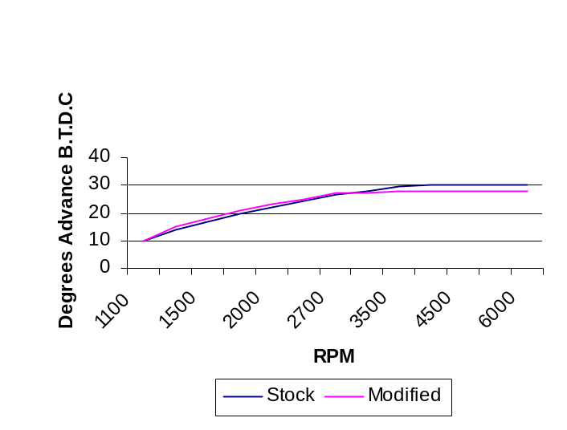
Production Costs
Based on the cost assessment outlined in the technology implementation cost analysis (TICA) spreadsheet, the cost of implementing the four-stroke engine to the snowmobile is $1551.30. Due to the increased fuel efficiency of the four-stroke engine, the added cost is projected to be offset by decreased fuel consumption and increased engine longevity over a period of time.
EXHAUST MODIFICATIONS
Modifications to the exhaust system of both engine options focussed on two primary areas: noise and emissions. Due to the fact that components used to reduce noise and tailpipe emissions affect the flow characteristics and performance of the exhaust system, noise and chemical emissions reduction solutions were development concurrently.
Emissions
In an effort to reduce emissions for both the engine configurations, the use of a catalyst was determined to be a feasible and effective method of reducing HC and CO emissions.
Four-Stroke Catalytic Converter Selection
A three-way oxidation/reduction (Pb/Pt/Rh) catalytic converter was used in the four-stroke application, similar to many automotive-style catalysts, with a cell density of 200 cells/inch². The oxidation catalyst was selected to reduce the HC and CO emissions and the reduction catalyst for NOx reductions.
Two-Stroke Catalytic Converter Selection
The durability of a catalyst in a two-stroke cycle engine, with regard to temperature and aging, is greatly influenced by the amount of scavenging losses. After running a two-stroke engine with large amounts of scavenging losses, the catalyst becomes loaded (restricted). One way to extend the life of the catalyst is to reduce the amount of scavenging [6]. Team Mavericks addressed this problem by developing Direct Fuel Injection.
Due to the fact that NOX emissions are lower on a two-stroke cycle engine, a two-way oxidation catalyst was selected. The scavenging in the two-stroke cycle engine has the same effect on NOx emissions as exhaust gas re-circulation systems of four-stroke cycle engines, eliminating the need for a reduction catalyst. In addition, research has shown that reduction catalysts actually cause an unacceptable rate of catalyst deactivation. Catalyst restriction is also increased when a reduction catalyst is incorporated into a two-stroke cycle engine.
In the two-stroke cycle engine, the backpressure must remain as low as possible. This will be accomplished by using a catalyst with only 100-cells/inch² versus the 200-cells/inch² used in the four-stroke engine.
Placement of the catalyst was a main concern in the design, as temperatures of at least 350° Celsius are necessary for ignition [6]. To ensure that temperatures are hot enough and that the catalyst will heat up quickly, it must be placed close to the engine and surrounded with hot exhaust gases. As the fresh charge of fuel and air mix in the first part of the expansion pipe, installing the catalyst at the stinger was an obvious choice.
Tuned Pipe
The exhaust tuning of a two-stroke cycle engine is crucial to the performance of the engine. The tuned expansion pipe is made of an expansion cone, a body and diverging cone. When the piston opens the exhaust expands into the expansion pipe, suction occurs in the cylinder, pulling a fresh charge of fuel and air through the cylinder and into the expansion pipe with the exhaust. A reflection wave is created when the exhaust reaches the diverging cone, which pushes the fresh charge back into the cylinder before the exhaust port closes. As the piston speeds increase, the exhaust port must stay open longer to allow for the same fresh charge of fuel to reenter the cylinder. In the closed range of the exhaust valve (0-5000 rpm), the delivery ratio is greatly improved with the variable exhaust system (VES). In the open range of the VES system (5000+ rpm), the engine will produce more power, as the exhaust port timing has been retarded by 12.2° [1].
The pipe was insulated to retain as much heat as possible; when the pipe is at the correct temperature, maximum air velocity is achieved, creating the correct airflow through the pipe. By insulating the pipe with a ceramic coating, the temperature holds constant from the engine to the stinger, where the catalytic convector was placed. To verify this constant temperature, seven thermocouples were installed in the expansion pipe and recorded on a Fluke Hydra, as seen in Figure 11.
Figure 11 Tuned Pipe with Thermocouples
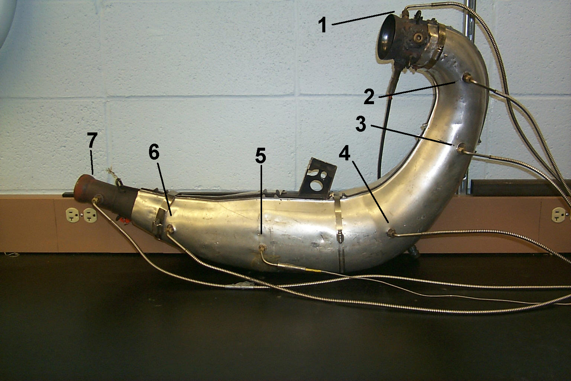
Thermocouple | 1 | 2 | 3 | 4 | 5 | 6 | 7
Temp ºC | 593 | 626 | 621 | 604 | 602 | 601 | 510

Measuring Sound
As each pipe length works only for a narrow band of frequencies, a spectrum analyzer was used to determine the frequencies holding higher decibel readings. Once the frequencies producing the most noise were determined, pipes of lengths corresponding to those frequencies were built into the muffler.
To test the effectiveness of these procedures, the engine was run without a muffler at the same rpm levels used at the CSC 2002 competition, reflecting competition testing of a wide open throttle. The engine was placed outdoors, negating the factor of sound reflection from walls. The microphone used to record the noise levels of the exhaust was positioned five feet directly behind the exhaust pipe, and a Brüel & Kjær Vehicle Signal Analyzer type 2145 interpreted the signal. The spectrum analyzer data was recorded, interpreted, and used to design the muffler configuration.
Muffler
Many aftermarket companies, in an attempt to design exhaust systems that produce more power, design units without considering the backpressure of the original system [7], which can result in a reduction of performance. The development process of the muffler began with flowing the complete stock exhaust system, including the tuned pipe. This procedure yielded the flow capacities of the total exhaust system including the tuned pipe. The goal of the modified design was to develop a system with the same backpressure.
A general misconception is that sound travels in waves, when in reality it travels in pressure charges [8]. These acoustics are cancelled by reflecting the pressure wave back to the opposite incoming wave; as the incoming high pressure meets a reflected low pressure, they combine and create a neutral pressure. The human ear picks up pressure waves as noise, so if a neutral pressure can be achieved, no sound is heard.
Temperature has a large effect on the speed of sound in air, as the two pressure waves must meet at the exact times the correct operating temperature is attained before sound cancellation occurs. A thermocouple measured the exhaust temperature entering the muffler at 463.9° Celsius. Equation 1 is then, used to calculate the velocity of sound in air at the measured temperature. Once the velocity is known, Equation 2 is used to determine the length of the pipe. This frequency is identical for both a closed pipe and an open pipe, as the larger volume of air at the end of an open pipe acts as a wall to reflect the acoustic pressure wave back into the pipe [9], which is called a helmholtz resonator. The advantage of using an open pipe is that a pipe can extend straight through the muffler, with only pipe size changing at key locations.
Equation 1 [1]
a₀ = √(1.4*287*T₀)
Equation 2 [10]
Length (meters) = Velocity (a₀)/ Temp. (T₀)
Once all the lengths were calculated and sound testing was completed. It was determined what frequencies were possible to be canceled within the space requirements of the snowmobile. The muffler was built by using 4 inch tubing and placed 2 inch pipes inside, as seen in Figure 12.
Figure 12 Picture of Mavericks’ Muffler
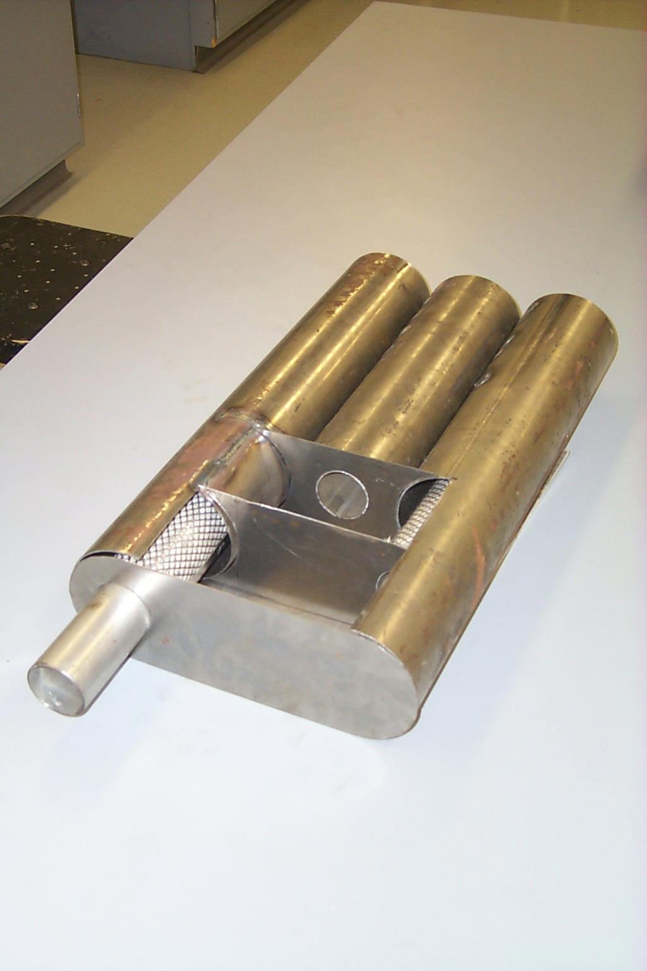

When the muffler was complete a comparison test was run, comparing the stock silencing system to the Maverick’s silencing system. The results are shown in Table 5.

Table 5 Comparison Test of Sound Systems
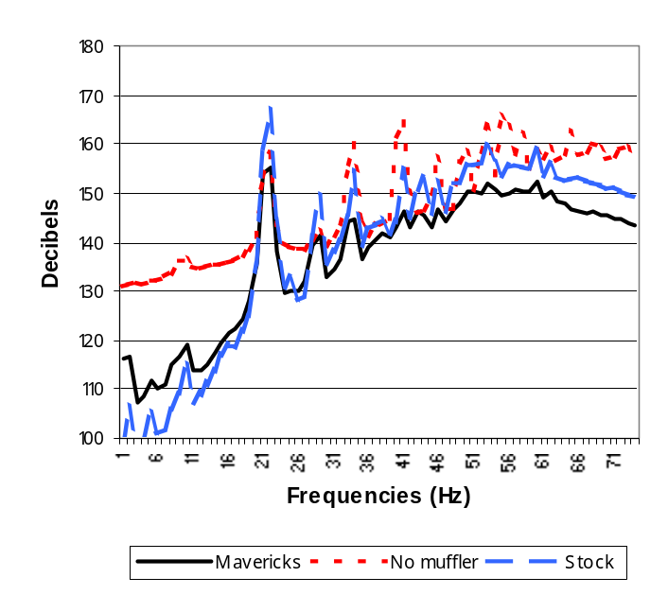
The analysis of noise emissions reduction was a large undertaking by members of the Mavericks team. According to Clean Snowmobile Challenge competition regulations, an entry that fails to pass the noise emissions standard is disqualified from receiving points in the combined acceleration run and may not be awarded best design.
Placement
The muffler was placed under the seat of the snowmobile to gain extra room under the snowmobile hood. This also transferred some of the under-hood weight to the back for a better weight-distribution ratio. The exhaust routes under a custom gas tank to the muffler located under the seat and exits the snowmobile into the tunnel. Theoretically the turbulence of the air caused by the track helps to further deaden exhaust noise.
CHASSIS MODIFICATIONS
The chassis used for the competition snowmobile was a 2001 Polaris Edge, which has several innovative features, such as CRC “Controlled Roll Center” front suspension and a proven Polaris Extra 10 rear suspension. Several modifications where made to the chassis for adaptation to the environmentally friendly engine to suit it to the demands of competition.
Seat Modifications
The seat was modified to accommodate the custom tunnel-exiting exhaust system. A cavity was necessary under the seat to house the muffler for the exhaust system, so the seat was hollowed out and an aluminum support fabricated to support the seat around the muffler. This exhaust cavity was lined with a 3M product, Nextel thermal insulation, to ensure driver safety.
Fuel Tank
In designing the exhaust system for the snowmobile, a new fuel tank was needed which could accommodate the muffler system. Room was needed to run an exhaust pipe under the fuel tank into the muffler cavity located under the seat.
An aluminum fuel tank was constructed with the appropriate cavity to allow the exhaust pipe to be directed under the tank and into the exhaust cavity, Figure 13.
Figure 13 Picture of Mavericks’ Gas Tank

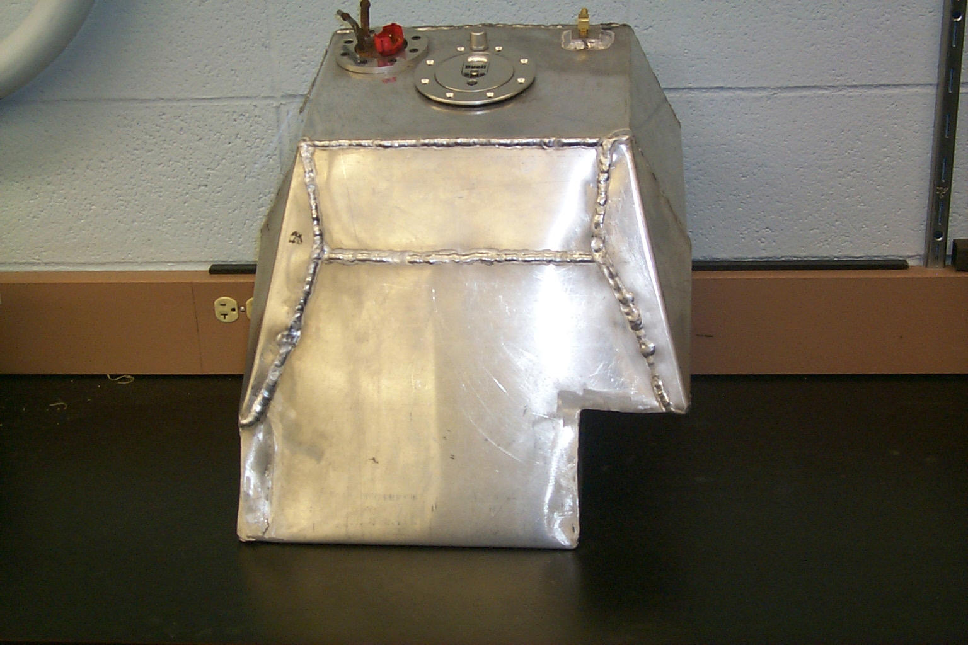
Track
In determining whether to use a long or short track for the competition, several points were addressed, and final decisions were made based upon the scope of the competition. Lighter weight was determined to be an advantage for several reasons. Horsepower loss from the engine to the ground is decreased when rotating mass is reduced. “It takes about 1 HP for each additional 7 pounds of weight added to the sled to maintain equal performance” [10]. Anything that adds weight or mass to the snowmobile will decrease performance in some way, but rotating mass creates a greater power loss than non-rotating mass. Non-rotating mass simply requires additional power to move it forward while rotating mass acts like a flywheel, absorbing and storing kinetic energy. This energy is therefore not available to accelerate or drive the snowmobile. The largest portion of rotating mass found on a snowmobile is the track. A 15 x 121 x 1.25 inch track will always accelerate faster than a 15 x 144 x 1.25 inch track, all other factors being equal [10].
Two tracks were tested for use in the snowmobile. The short track weighed 37.6 lbs., while the long track weighed 44.2 lbs. with an additional 4.2 lbs. for rail extensions. The lighter track was considered more beneficial to the snowmobile, translating into increased fuel efficiency and a corresponding decrease in emissions. As rotating mass acts as a flywheel, absorbing kinetic energy, a track with more mass will absorb more kinetic energy, or engine horsepower. With the lighter track, less power is needed to rotate the track, and as a result, increased fuel efficiency is achieved.
The flywheel effect caused by rotating mass also affects the snowmobile’s braking ability. The flywheel effect not only absorbs kinetic energy, but also stores it, which causes a greater inertia force. The braking energy required is directly proportional to the amount of inertia built up in the rotating mass.
In consideration of the long versus the short track, use of the short track also means a reduction in noise. A long track has more contact with the ground and moving parts in the drive train, causing increased noise. Testing was conducted to determine the increase in noise of the long track and was determined to be approximately two decibels louder at all speeds. Table 6 shows a graph of the results.
Table 6 Long Track vs. Short Track Noise
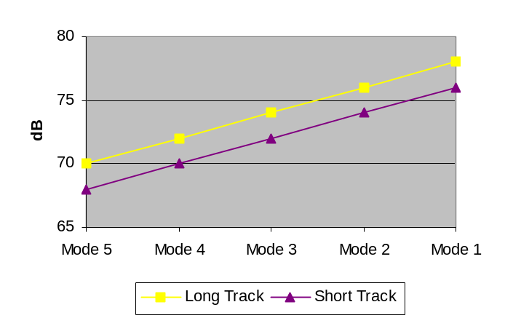
The short track is also more reliable than the long track, as it does not have bolt-on rail extensions that have a high incidence of breakage. Factory long-track rails are stronger than long-track rail extensions, but still act like a long torque arm and have a greater chance of bending than short track rail extensions.
A 121-inch Camoplast Predator track with 1.25-inch lugs was selected for the snowmobile. With this aggressive lug design, the track has the traction needed for competition without adding the unwanted weight of a long track. The track is designed with rubber picks in the lugs, which act as studs to aid in traction for acceleration and braking.
Another modification made was the addition of custom fabricated rear bogie wheels. In designing the bullet aluminum wheels, weight, strength, and efficiency were addressed. The rear wheels were fabricated from aluminum to keep weight to a minimum. Spokes were cut into the wheels to reduce weight, but were kept wide enough to ensure strength. Horsepower efficiency was aided by the use of aluminum, as the rubber in factory wheels becomes hot due to friction with the track and begins to stick.
TESTING
The testing portion of this project was divided into four specific areas: power, emissions, noise, and fuel efficiency. Comparisons of the two-stroke cycle and four-stroke cycle solutions were made for each area.
A water brake dynamometer from Land & Sea was used to measure horsepower and torque data for both engines and to make performance comparisons from stock to modified engines. The dynamometer was also used to place a load on the engines to define the fuel map and other parameters for the MoTeC. The dynamometer aided all finite engine adjustments made to maximize the horsepower output of the engine.
Fuel Choice
Internal combustion engines can also be fuelled from renewable energy sources [2]. Spark ignition engines run satisfactorily on alcohol-based fuels [2]. Alternative fuels such as ethanol burn cleaner than gasoline. This is due to the dissolved oxygen in the fuel that helps promote a better burn. Oxygenated fuels, including ethanol, have been demonstrated to significantly lower CO emissions when used. Thus, a 10% ethanol blended fuel was used.
Emissions Testing
The five-mode emission test cycle, developed by Southwest Research Institute, was conducted on each engine. Emissions were measured using a California Analytical Instruments raw gas system. A heated flame ionization detector (HFID) measured unburned HC; non-dispersive infrared (NDIR) analyzers measured CO and CO2; a chemiluminescent analyzer (CLA) measured NOX; and a paramagnetic analyzer measured O2. Emission levels of the unmodified engine exceeded the calibrated ranges of the analyzers, so a repair-grade infrared exhaust analyzer was used. The test modes were conducted using the following values: the two-stroke cycle engine held a baseline peak horsepower of 97, with a peak operating rpm of 8150, and the four-stroke cycle engine held a baseline peak horsepower of 42, with peak operating rpm of 5900. The test modes were run in order from lowest to highest speed and were performed as shown in Figure 14.
Figure 14 Emissions Test Procedure
Emissions data from the four-stroke baseline and two-stroke baseline is shown in Table 7. This data revealed typical differences between two-stroke and four-stroke cycle unmodified engines. Table 8 shows the emissions data comparing the stock and modified four-stroke. Data for the modified two-stroke engine was unable to be obtained due to extremely high exhaust pipe temperatures.
Mode | % RPM | % Horsepower
Mode 1 | 100 | 100
Mode 2 | 85 | 51
Mode 3 | 75 | 33
Mode 4 | 65 | 19
Mode 5 | Idle | 0
Table 7 Emissions of Both Stock Engines
Comparison of 2 and 4-Stroke Emissions
 | 2-Stroke |  |  | 4-Stroke
Mode | HC (C1) | CO | NO_{X} | HC | CO | NO_{x}
1 | 35520 C! | 6.5 | 430 | 1776 | 4.4 | 1206
2 | 52800 | 7.7 | 475 | 2989 | 2 | 1679
3 | 52800 | 6.2 | 425 | 1514  1514 | .2 | 889
4 | 38400 | 2.6 | 270 | 128 | .1 | 300
5 | 84480 | 3.3 | 400 | 2946 | 2.3 | 52

Table 8 Emissions of Four-Stroke Stock vs. Modified
Comparison of 4-Stroke Emissions
 | Stock |  |  | Modified
Mode | HC | CO | NO_{x} | HC | CO | NO_{x}
1 | 1776 | 4.4 | 1206 | 1730 | 5.7 | 20
2 | 2989 | 2 | 1679 | 1719 | 3.9 | 84
3 | 1514  1514 | .2 | 889 | 1413 | 3.4 | 40
4 | 128 | .1 | 300 | 360 | .3 | 19.3
5 | 2946 | 2.3 | 52 | 3935 | 5.3 | 52

Fuel Economy
Brake specific fuel consumption values on the base engines are presented in Table 11.
Table 11 Brake Specific Fuel Consumption
Mode | 2-Stroke | 4-Stroke
 | Baseline | Baseline
1 | .514 (.846) | .373 (.613)
2 | .630 (1.036) | .335 (.551)
3 | .701 (1.152) | .382 (.628)
4 | .557 (.916) | .555 (.913)
5 | 7.987 (13.136) | 2.437 (7.987)

Brake Specific Fuel Consumption in Kg/Kwh (lb/hphr)

COST ANALYSIS
Throughout the development and construction of the two test engines, costs of all modifications were taken in consideration. The technologies implemented to the snowmobile are to be cost-effective as stated in the Clean Snowmobile Challenge 2002 rules. Tables 12 and 13 show the total costs of the modifications to the two power plant systems.
Table 12 Four-Stroke Cost Analysis
Subsystem | Subtotal
Induction System | $900.00
Fuel System | 111.00
Engine | 450.00
Exhaust Aftertreatment | 25.00
Electronics | 183.00
Noise Treatment | 75.72
Technology Implementation Total Cost, Turbo four-stroke cycle engine | $1,744.72

Table 13 Two-Stroke Cost Analysis
Subsystem | Subtotal
Induction System | $ -
Fuel System | 250.00
Engine | 350.00
Exhaust Aftertreatment | 110.00
Electronics | 268.00
Noise Treatment | 30.00
Technology Implementation Total Cost, DFI two-stroke cycle engine | $1,008.00

Although additional costs exist in implementing the two systems, based upon BSFC of the test engines during testing and the fuel economy of the test snowmobile from the CSC 2001 competition, the additional fuel economy of the modified engines would overcome the costs of the engines over the life of the snowmobiles.
conclusions
Throughout the design and implementation of the two engine choices, many factors were affected by the general scope of the competition. The guidelines of the competition stated that the design should be practical, cost effective, and durable. Both engine choices could be effectively implemented into the snowmobile, however an engine choice of the four-stroke engine was made. The four-stroke cycle turbocharged engine was found to be a cleaner design, while continuing to give the rider the traditional feel of a snowmobile due to the additional power offered by the turbo. The turbo system was found to raise horsepower of the four-stroke cycle from 42 to 65 HP, which made the four-stroke cycle engine a reasonable choice for the Clean Snowmobile Challenge.
This competition gave all of the team members an opportunity to express their ideas, and apply their knowledge and expertise. Each team member learned from the others and gained knowledge and experience throughout the project.
Results
Although testing and development of the engines went very well, the competition brought on more challenges and durability issues. Due to a lubrication problem early on at the competition in the four-stroke engine, the engine had to be replaced. The backup engine was used with about 4,000 miles. This engine was used then to complete the competition, however the high mileage of the engine created further problems.
Initially the snowmobile ran very well producing about 75 MPH at 6800 RPM and excellent acceleration. Performance was close to that of a smaller two-stroke. During the durability event a crack in the exhaust led to lower turbo boost and a rich mixture. This caused problems internally in the engine, which was later found to be cracked piston ring lands. This led to excessive blow by and an underpowered engine.
Due to the engine problems encountered the snowmobile failed emissions, did not finish in the fuel economy event, only made one run in the acceleration/ noise event, did not compete in the handling event, and only made it part way up the hill climb. Had the snowmobile finished the noise event the noise emissions were low enough to pass the event. Noise was lowered from 78-dB stock to 72-dB with the noise treatment used.
The team finished second for the technical paper, sixth for the oral presentation, but finished last overall. The team did however win the sportsmanship award for the competition. Although all did not go as planned at the competition, much was learned during the project and new ideas and solutions for next year are already coming together.
Acknowledgments
Minnesota State University MSU Mavericks would like to thank the following individuals and organizations for their contributions and participation in the Clean Snowmobile Competition:
- Headline Sponsors

Platinum Level
Flagg Ranch Resort
Montana Department of Environmental Quality
Wyoming Department of Environmental Quality

Gold Level
Institute of Science, Ecology, and the Environment
International Snowmobile Manufacturers Association
Teton County Wyoming
U.S. Department of Energy (Pacific Northwest & Alaska Regional Bioenergy Program)

Silver Level
Jackson Hole Mountain Resort
Jackson Hole Snow Devils
National Park Service
Ontario Federation of Snowmobile Clubs
Peaks to Prairies Pollution Prevention Information Center
Sports Car Club of America, Inc.
Town of Jackson, Wyoming

Bronze Level
American Council of Snowmobile Associations
Blue Ribbon Coalition, Inc.
Dana Corporation/Long Manufacturing
Snow King Resort
Utah Snowmobile Association
Western Chapter of the International Snowmobile Council
West Yellowstone Chamber of Commerce, Snowmobile Events Committee
Wyoming Business Council
Wyoming Ethanol

Supporter Level
Antler Motel
Bombardier Motor Corporation of America
Washington State Snowmobile Association
Wyoming State Snowmobile Association

Contributor Level
Bullwinkle's Saloon, Gambling & Eatery
California Nevada Snowmobile Association
Sweetwater County Snowpokes
Vaughan Distributing

- Competition Administrators
The Society of Automotive Engineers
The Institute of Science, Ecology, and the Environment
Dr. Lori M. Fussell

- Minnesota State University, Mankato Sponsors
3M
Brainerd Snodoes
CoolCar
Competition Cams
Donaldson Filtration Systems
Gopher Engine Remanufacturing
Hotseat Performance
Koolmat
Lube Tech Lubrication Technologies, Inc.
Minnesota Corn Growers Association
Minnesota Department of Commerce
Minnesota United Snowmobiler's Association
Nelson Industries, Inc.
OMG Automotive Catalyst
Polaris Industries
Siemens VDO Automotive
Suburban Mold, Inc.
Sport Tech
Swain
Toro
Western Power Sports
Williams
Zoom Graphics

References
- G. Blair, 1996, Design and Simulation of Two-Stroke Engines, Society of Automotive Engineers.

- R. Stone, 1999, Introduction to Internal Combustion Engines, 3rd edition.

- J. Heywood and E. Sher, 1999, The Two-Stoke Cycle Engine: Its Development, Operation and Design. Braun-Brumfield.K,

- K. Cameron, “Problems With DFI,” Snow Tech Magazine, December, 1999, 62-69.

- G. Jennings, 1973, Two-Stroke Tuners Handbook. H.P. Books.

- R. Douglas, R.J. Kee, G. McCullough and A.P.N McDowell, “Catalyst Deactivation on a Two-Stroke Engine,” SAE Technical Paper 982015(1998).

- McTheters, Derrik. Hotseat Performance
(651) 873-2427.

- Kinsler, Lawerence, Frey, Coppens and Sanders, Fundamentals of Acoustics, John Wiley & Sons, Inc., 1982.

- Schumacker, Kory, Project Engineer-Accoustica Products, Fleetguard/Nelson
(608)873-2427.

- Cutnell, John and Kenneth Johnson, Physics, 5th edition, John Wiley & Sons, Inc., 2001.

- Mickelson, Phil, “Weighty Matters,” SnowGoer Magazine, November, 2001, 46, 47.

Definitions / ACRONyMS
CO – Carbon Monoxide
DFI - Direct Fuel Injection
HC - Hydrocarbon
HPDI - High Pressure Direct Injection
NOx – Nitrogen Oxides
Turbo lag – The time needed for a turbo-charger to reach operating pressure.

