Neighborhood Electric Vehicle Progress Report 4/7/08
(NEV) to Plug-in Hybrid Agreement # B08399

Garett Soukup, Chris Henney, Chris Adams, Dr. Bruce Jones and Dr. Vince Winstead
Sean Wimer, Kyle Rose, Tony Kunkel, and Drew Kindschi Faculty Advisors

BACKGROUND
This is a two year project funded by a grant from the Minnesota Department of Commerce for hybrid development. The purpose of this project is to transform an electric vehicle from e-ride Industries to a plug-in hybrid electric vehicle by integrating a genset from Cummins Power Generation. The transformation from an electric vehicle to a hybrid will be beneficial in that it will have a greater operating range than an electric vehicle while keeping emissions lower than a conventional automobile.

SUMMARY
The work on the project to date has focused on the continued development of the test loops and debugging the data acquisition system. In addition the genset has been integrated into the vehicle and testing has been completed on both gasoline and also E85. It is anticipated that the final paper for the first year of the project will be completed at the end of July.

TEST LOOPS
Three test loops have been developed. The first test loop represents driving on paved roads and parking lots with several starts and stops. The second loop is a “terrain” loop that is unpaved with several small hills and inclines designed to represent “off road” applications. The final loop is a “hills” loop that measures the performance of the vehicle on steep inclines. Test procedures for each loop have been developed and modified in an effort to remove all variability.

DATA ACQUISITION
The data acquisition system has been completed and configured to collect the desired data under all conditions. Final configuration of the system had to be completed during initial test runs on the various loops.

GENERATOR
The genset has been broken in and is running properly. A fuel tank and evaporative emissions system was integrated into the vehicle and is located under the hood of the unit. (Figure1)

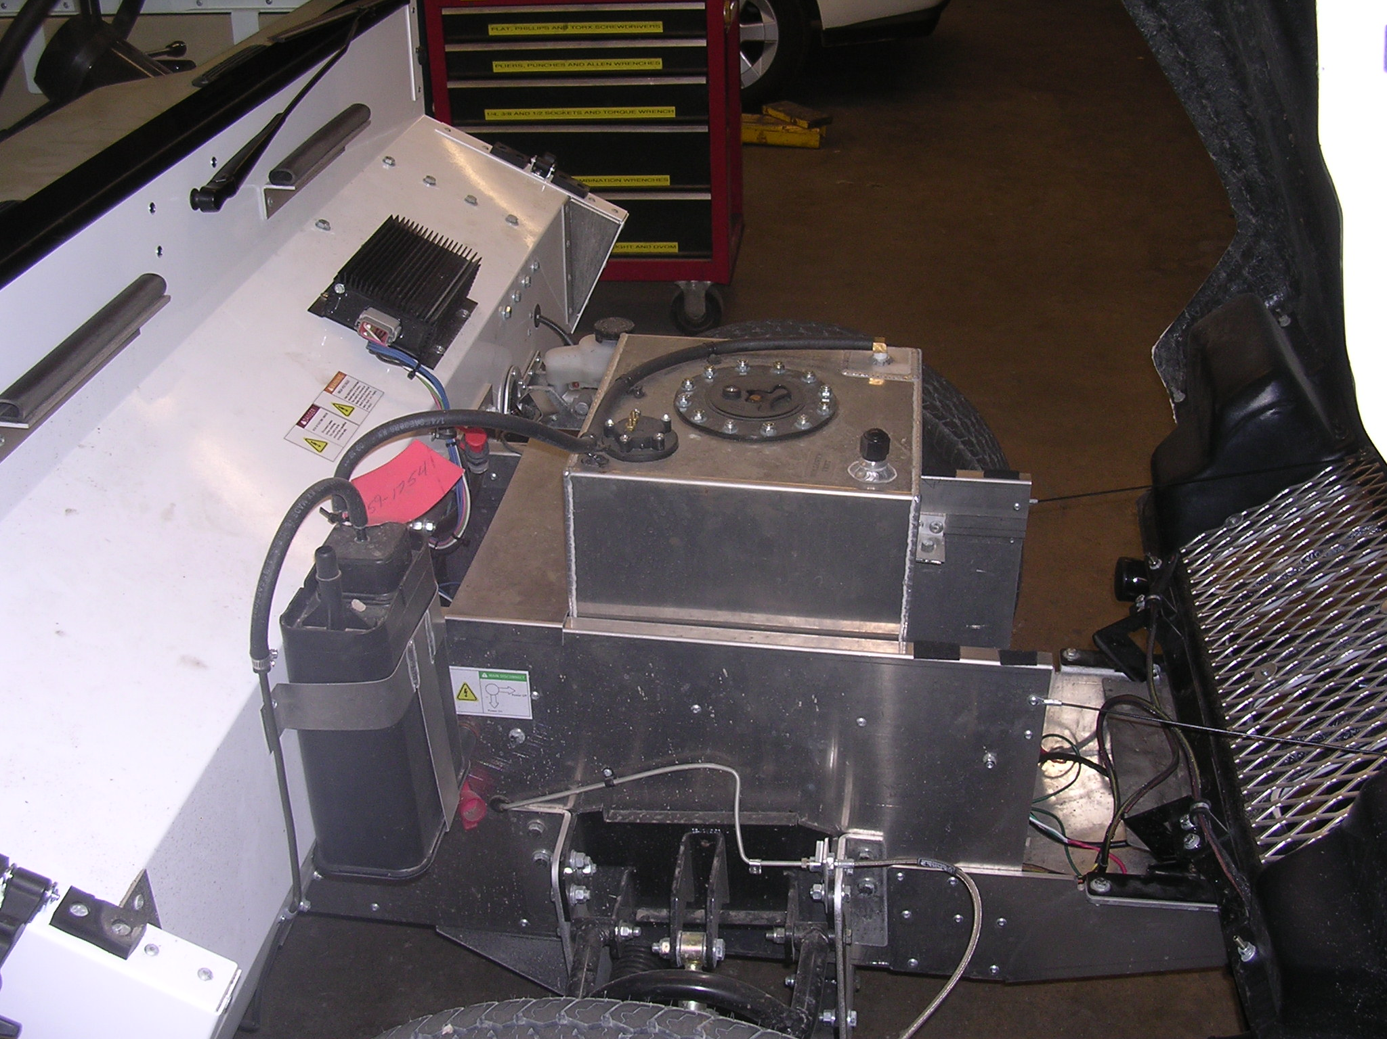
Figure 1

Additional sound deadening material has been incorporated into the vehicle where the genset is located. Baseline noise testing was conducted without additional sound deadening material and again after the addition of UltraBarrier Plus. The material consists of individual layers: 0.250in decoupling foam; a 0.125in. sound blocking barrier; a 1in. sound absorbing foam; and 0.003in of reinforced aluminum facing.
Controls to turn the genset on along with an electrical outlet for power tools have also been installed. The generator on/off switch and hour meter can bee seen in figure 2.
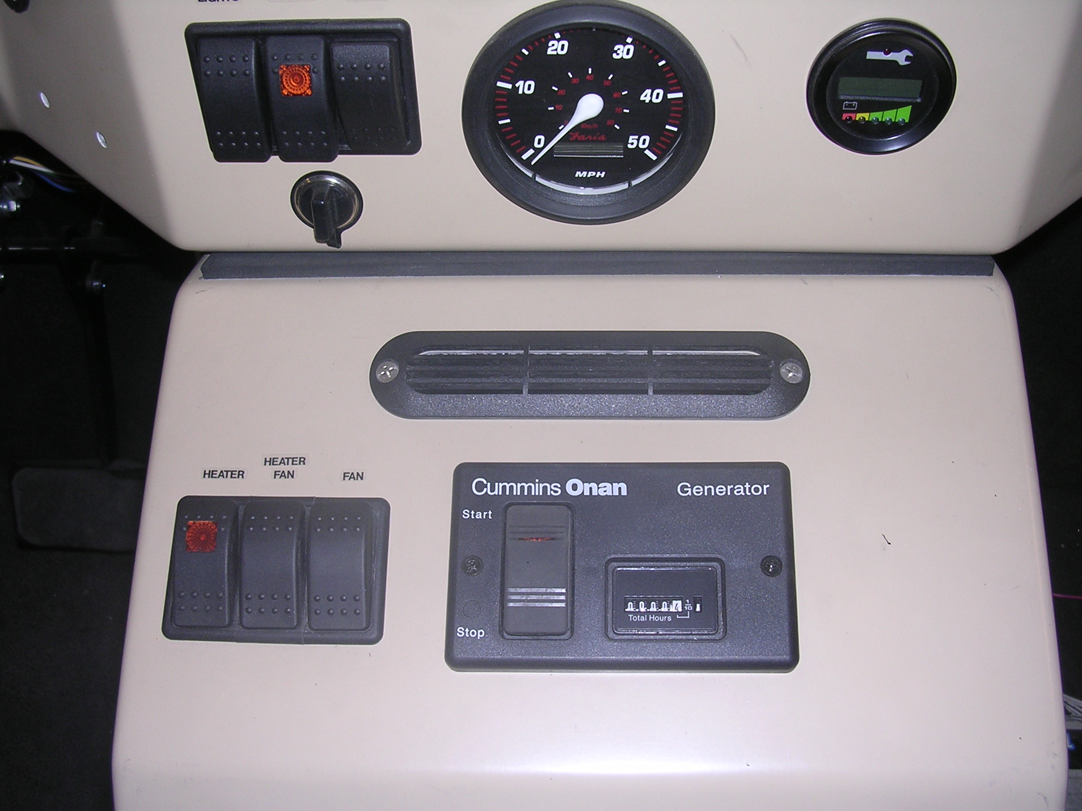
Figure 2
Finally, the emission and fuel consumption characteristics of the genset have been measured following EPA testing protocol. Figure 3 shows the genset prepared for emission testing in the MnCAR lab. Testing has been completed on base gasoline and also after the unit was converted to run on E85.
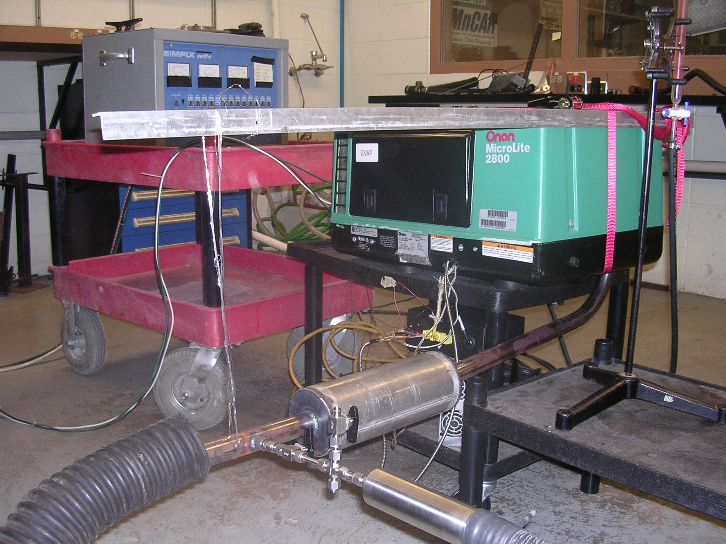

Figure 3

