AET/MSU 000
MAY/12/2003
ETHANOL BIO-DIESEL RESEARCH PROJECT

Andy Mickelson, Tyler Uilk, Ves Ndjarakana, Alfred Samuel
Automotive Engineering Technology, Minnesota State University

Dr. Bruce Jones
Faculty Advisor

ABSTRACT

The purpose of the research was to test a blend of 5% ethanol, 10% Bio-Diesel, and 85% #2 Diesel fuel (EB-Diesel) on an off road engine. All tests were compared to the results of #2 Diesel without ethanol or Bio-Diesel. The ISO 8178 Emission Test Cycle Procedure was followed for all testing. Part of the project was to collect data as well as to analyze results and give recommendations for future research.

iNTRODUCTION

This paper contains procedures and results conducted by the Minnesota State University, Mankato’s Automotive Engineering Technology Program. Testing was conducted in the following areas: Engine Performance, Power Testing and Emissions. All the tests were conducted on a 31 HP Duetz engine coupled with a Katolight 15kW generator. A photograph of the generator set that was used for the project is shown on Figure 1.

One of the problems with Diesel engines is that they produce a lot particulate emissions as well as NOx emissions. Mixing ethanol with Diesel fuel helps lower combustion temperatures, which in turn may lower NOx emissions. The use of ethanol with Diesel also lowers particulate emissions.

However, ethanol potentially has some negative effects. For example, ethanol lowers the flash point of E-Diesel, which affects storage and handling. For this reason, engine manufacturers have expressed concerns regarding the safety of storing the blends in conventional fuel tanks. Southwest Research Institute in San Antonio, Texas, is currently investigating the safety issue surrounding E-Diesel blends. Another negative effect of ethanol is that it lowers the cetane number of E-Diesel, which results in substandard engine performance. Ted Aulich, of the Minnesota Soybean Grower’s Association, submitted similar statements during the Bio-Diesel Research and Brainstorming Workshop that took place January 29-30, 2003 in New Orleans, Louisiana.

HP 28Kw @1800 rpm
Bore 3.58 in. (9.1 cm)
Stroke 4.13 in. (10.5cm)
Displacement 125 cu in (2.05 L)
BMEP 99psi (685kPa)

Running Diesel engines on blends of ethanol, Bio-Diesel and #2 Diesel could offset some of the shortcomings of ethanol. Bio-Diesel raises the cetane number of the fuel blend. It also helps in lubricating the metal parts in the fuel system.

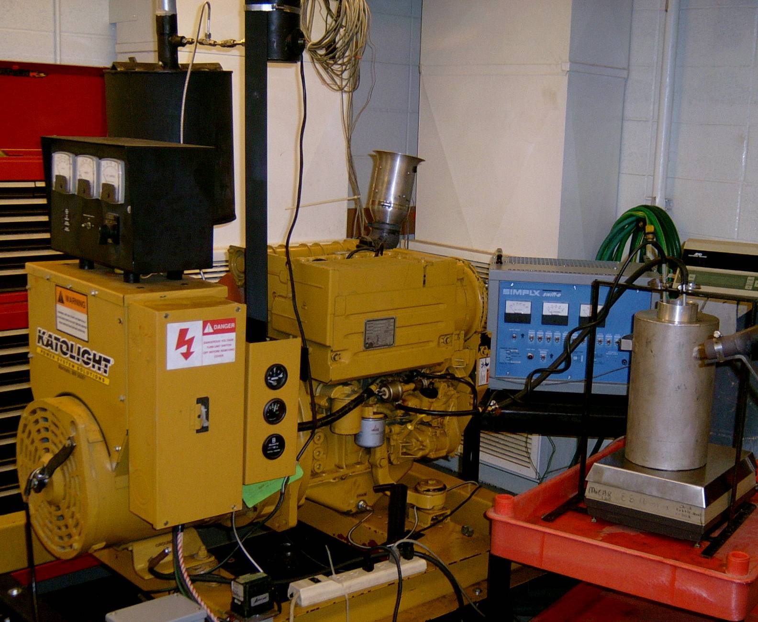
Figure 1

TEST ENGINE

The engine that was used for this research was a three cylinder, inline air-cooled Duetz diesel engine coupled with a 15Kw Katolight generator. The engine specifications are given on below.

A Simplex portable load bank was used to absorb and control the power output. The model used was a Swift-E Plus, 15 Kw, 120/240 volt, single-phase, 60 Hertz with a 250-watt step resolution. With this resolution the load settings required for the ISO 8178 were easily attained.

FUEL FORMULATIONS

A set of 25 samples with different blends of ethanol, Bio- Diesel and #2 Diesel were prepared and sent to Williams Laboratory Services to be tested for Flash Point and Reid Vapor Pressure. The Flash Point is a measure of how easily the fuel ignites, not only in the engine but also in storage. Fuels with lower flash points have the ability to ignite readily. Reid Vapor Pressure is a measure of the volatility of the fuel. Fuels with higher Reid vapor pressure are more volatile. This is a concern in the testing of ethanol diesel fuels, because ethanol is naturally very volatile.

The objective of this exercise was to find a blend of ethanol, Bio-Diesel and #2 Diesel that would have a flash point and volatility that meet the accepted values of #1 Diesel. It was felt if the blend met those levels it could be easily used in existing systems without modifications. Test results from Williams Laboratory services are shown on Table 1.

Table 1

Blend | ASTM D93 | ASTM D5191
 | Flashpoint | RVP
 | Deg. F | PSI
0E, 0B, 100D1 | 100 | 1.39
0E, 0B, 100D2 | 153 | 0.09
0E, 0B, 100D2 | 155 | 0.33
0E, 2B, 98D2 | 153 | 0.58
0E, 2B, 98D2 | 153 | 0.06
0E, 5B, 95D2 | 155 | 0.15
0E, 10B, 90D2 | 159 | 0.46
0E, 20B, 80D2 | 163 | 1.57
0E, 100B, 0D | 300 | -0.12
2E, 2B, 96D2 | <72 | 2.18
2E, 5B, 93D2 | <72 | 1.12
2E, 10B, 88D2 | <72 | 1.17
2E, 20B, 78D2 | <72 | 1.19
2E, 10B, 88D2 | <72 | 1.13
5E, 5B, 90D1 | <72 | 1.87
5E, 5B, 90D2 | <72 | 1.83
5E, 10B, 85D2 | <72 | 1.93
5E, 10B, 85D2 | <72 | 1.8
5E, 5B, 90D1 | <72 | 1.89
5E, 20B, 75D2 | <72 | 2.2
5E, 5B, 90D2 | <72 | 2.15
10E, 10B, 80D2 | <72 | 2.42
10E, 20B, 70D2 | <72 | 1.96
100E, 0B, 0D | <72 | 3.28

Key:
E | Ethanol
B | Bio-diesel
D1 | #1 Diesel
D2 | #2 Diesel

The numbers preceding the letters represent the percentage by volume of ethanol, Bio-diesel, #1 Diesel and #2 Diesel.

The results showed that even with the addition of 2% ethanol the flashpoint dropped below the allowable #1 Diesel fuel value of 100 degree Fahrenheit. Determining the flashpoint of blends below room temperature (72 degree Fahrenheit) needed further expensive testing and there was not sufficient funds to have such tests conducted. It was decided a 5% Ethanol, 10% Bio-diesel, and 85% #2 Diesel blend should be used to conduct emissions testing.

FUEL BLENDING PROCEDURE

50 gallons of #2 Diesel was purchased from Southern Valley Co-op on April 24, 2003 to serve as the base fuel for all tests. 20 gallons of Bio-Diesel was purchased from the Cannon Valley Co-op in Northfield, Minnesota. 20 gallons of E95 was obtained from Corn Plus, an ethanol plant in Winnebago, Minnesota. The specific gravity of all fuels were measured at 70 degrees Fahrenheit, and the readings are shown on the Table 2 below

Table 2

 | Specific Gravity | % Of solution
#2 Diesel | 0.8695 | 0.85 | Base Fuel
Additive | 0.882 | 0.1 | Bio-Diesel
E-95 | 0.787 | 0.05 | E-95

The fuel was splash blended into 5-gallon jugs. All weighing was done using a digital gram scale of 0.1 gram resolution. The first step of the fuel mixing procedure was to fill the jug with approximately 4.25 gallons of #2 Diesel. The mass of the #2 Diesel was determined by taking the difference between the mass of the jug with Diesel and the mass of the empty jug. Using the specific gravities of E95 and Bio-Diesel, the amount of grams needed was calculated using a spreadsheet. The complete mixing table is presented in Appendix A. An example of the calculations used to blend the 5% Ethanol, 10% Bio-Diesel and 85% Diesel, are shown below.

1. Mass of jug with Diesel = 15630.5 grams
Mass of empty jug = 1631 grams
Mass of Diesel = 13999.5 grams

2. Converting from grams to gallons of Diesel

Grams of fuel/specific gravity (g/cc)
3785.41cc/gal

(13999.5 g / 0.8695 g/cc)/3785.41 cc/gal

=4.2533371gal

3. Finding total volume of 100% of the blend

# of gallons of #2 diesel / 0.85

4.2533371gal * 0.85 = 5.003926052 gal

4. Finding # of gallons of E95

Total volume * 0.05

5.003926052 gal * 0.05 = 0.2501963 gal

5. Converting gallons of E95 to grams

Volume of E95 X specific gravity

(0.2501963 * 3785.411784)cc * .787 g/cc =

745.36458 g

6. Finding the Volume of Bio Diesel

Total volume * 0.1

5.003926052 * 0.1 = 0.50039261gal

7. Converting gallons of Bio-diesel to grams

Volume of Bio-Diesel X specific gravity

(0.50039261 * 3785.411784)cc * .882 g/cc =

1670.677401 g

FUEL EFFICIENCY

The objective of the fuel efficiency test was to determine the difference in the rate of fuel consumption between the EB-Diesel compared to #2 Diesel. Fuel efficiency is a function of the heating values of the different fuels.

EMISSION TESTING

All emissions testing was conducted at the Minnesota State University Center for Automotive Research (MnCAR). The tests were done following the ISO 8178 type C1 standard, which is designed for off road stationary engine applications. This is a five-mode steady state test cycle where by emissions are tested in steps of 100%, 75%, 50%, 25% and 10% of the maximum load at the rated speed of 1800 rpm. The emissions measured were hydrocarbons, methane hydrocarbons, oxides of nitrogen, carbon dioxide, carbon monoxide, and oxygen in addition to particulate emissions.

To measure gaseous emissions California Analytical Instruments Emission Equipment was used. The emission analyzers consisted of the following:

CAI 300 M-HFID Heated Flame Ionization Detector Methane Analyzer

CAI 300-HFID Heated Flame Ionization THC Analyzer

CAI 300-CLD Chemiluminescence NO_{x} Analyzer

CAI 300 NDIR Non-Dispersive Infra-Red CO and CO₂ Analyzer

CAI Paramagentic O₂ Analyzer

An OTC Diesel Smoke Opacity Meter, model 3405, was used to measure particulate emissions. The opacity meter measures the amount of light that can go through the smoke coming from engine exhaust. An engine producing more particulate emissions will have high opacity readings. The opacity meter logs opacity versus time in a line graph.

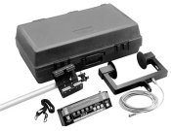
Figure 2

PROCEDURE FOR EMISSIONS TESTING

The gaseous and particulate emission levels were determined using the same procedure. Each test was conducted three times for each fuel. One set of tests were done using the base (#2 Diesel), followed by a set of the test fuel (EB-Diesel) and a final set of tests on the base fuel again. The procedure below was followed for each load setting.

Run engine until oil temperature is in the range of 198ºF to 203ºF
- Set load on load bank
- Turn on generator
- Set RPM to 1800
- Begin recording
- Run engine 3 minutes
- Stop recording
- Repeat for all the other modes

The procedure for changing from one fuel to the other included replacing the fuel filter with one that was pre-filled with the new test fuel. The engine was run for five minutes, under varying loads with the return line placed in a waste container. After 5 minutes the Specific Gravity of the fuel from the return line was measured to ensure that all of the old fuel had been purged. The engine was run each of the five loads for two minutes separately to ensure proper conditioning.

The complete gaseous emissions test setup procedure is located in Appendix B. The opacity test setup procedure is located in Appendix C.

TEST FUEL ENERGY DENSITY

The heating values of the different fuels are shown in Table 3.

Table 3

Fuel | Heating Values (Btu/gal)
Bio Diesel | 128,000
#2 Diesel | 130,000
Gasoline | 114,000
Ethanol | 76,000
E95 | 77,900
Test Fuel | 127,195

The ethanol used in the study was denatured with 5% gasoline. The following are calculations done to find the heating values of E95 and that of the Test Fuel.

E95 = 95% Ethanol + 5% Gasoline

= .95%*76,000Btu/gal + .05*114,000Btu/gal

= 72,000Btu/gal + 5,700Btu/gal

= 77,900Btu/gal

Test Fuel = 5% E95+10%Bio diesel + 85% #2 Diesel

= 0.05 * 77,900Btu/gal + 0.1 * 128,000Btu/gal + 0.85 * 130,000Btu/gal

= 3,895Btu/gal + 12,800Btu/gal + 110,000Btu/gal

= 127,195Btu/gal

(130,000 – 127,195) * 100/130,000 =2.16%

The heating value of the EB-Diesel blend is lower than that of #2 Diesel by 2.16% as show in the calculation above.

ENGINE PERFORMANCE

ENGINE POWER

A Fluke Hydra Data Logger was used to determine the power output the genset. This was achieved by measuring the voltage across the load bank and the current through the load bank and then multiplying the two readings at every interval to find the power generated.
The power of the engine was then determined by dividing the power from the generator by the efficiency of the generator using performance data obtained from Katolight Inc. This data is shown in Appendix D.

RESULTS

GASEOUS EMISSIONS

The percentages of elements that make up the EB-Diesel were calculated and the results are shown in Table 4. The percentages of hydrogen (H), carbon (C), oxygen (O), nitrogen (N), and sulfur (S), of the test fuels were required for the emissions analyzers to correctly determine emission levels. The values were calculated for each component based on the chemical formula for each fuel.

The chemical formula of ethanol is C₂H₅H.The following are the calculations for the molecular weight of ethanol:
Weight = 2C+6H+O
=2 * 12.01 + 6 * 1+16 = 46.02

%C in ethanol = 2 * 12.01/46.02 * 100 = 52.19

%0 in ethanol = 16/46.028100 = 34.77

%H in ethanol= 6 * 1/46.02 * 100 = 13.07

The chemical formula used for gasoline was C₈H₁₈. This value was chosen to represent gasoline. Gasoline comprises 84.22% C and 25.78% H. Tests results done within the previous EB-Diesel project showed that #2 Diesel contained 85.08% C, 12.77%H, 2.25% N and 1.08% S.

Bio-Diesel comprises 12% palmitic acid, 5% stearic acid, 25% oleic acid, 52% linoleic acid and 6% linolenic. From calculations done using the chemical formulas of the above acids it was discovered that Bio-Diesel contains 77.20% C, 10.98% 0 and 11.86% H.

Table 4

Element | 5%  E95 | 10%  Bio-diesel | 85%  Diesel | EB-Diesel
% C | 82.6 | 77.20 | 85.080 | 84.16
% O | 1.71 | 10.98 | 0 | 1.83
% H | 15.66 | 11.85 | 12.770 | 12.82
% N | 0 | 0 | 2.25 | 1.91
% S | 0 | 0 | 1.080 | .91

The following is an example for the % C in a blend of 5% Ethanol, 10% Bio-Diesel and 85% Diesel:

% C in E95 = 5 % C in Gasoline + 95% C in Ethanol = 82.6

% C in Bio-diesel = 77.20

% C in # Diesel = 85.08

%C in EB-Diesel =
0.05 * 82.6 + 0.1 * 77.2 + 0.85 * 85.08= 84.16%

Tables 5 and 6 below have gaseous emissions results (in grams per horsepower hour) with weighting factors for the different test modes.

Mode 1 was weighted at 0.05, Mode 2 at 0.25, Mode 3 at 0.3, Mode 4 at 0.3 and Mode 5 at 0.1. The energy density of each fuel blend was determined. The amount of energy in a fuel directly affects the volumetric fuel consumption of an engine. Generally speaking more fuel will be required to do the same amount of work when it has a lower energy density. For instance, Modes 3 and 4 are weighted the highest because the genset will typically be run between 50% or 25% of the load. Concise versions of the results are shown in Tables 5, 6, 7 and 8. The detailed gaseous emissions results for each mode and test are shown in Appendix E.

Table 5
#2 Base Diesel - Raw Average (g/bhp*hr)

 | Mode1 | Mode2 | Mode3 | Mode4 | Mode5
HC | 0.03 | 0.16 | 0.38 | 0.81 | 0.74
CO | 0.00 | 0.00 | 0.00 | 0.00 | 0.00
CO2 | 19.72 | 101.58 | 144.46 | 200.30 | 118.91
NOX | 0.39 | 2.92 | 3.27 | 2.90 | 1.46
O2 | 9.37 | 111.90 | 304.34 | 790.59 | 694.97

Table 6
#2 Base Diesel - Weighted (g/bhp*hr)

 | Mode1 | Mode2 | Mode3 | Mode4 | Mode5
HC | 0.0015 | 0.004 | 0.114 | 0.243 | 0.07
CO | 0.00 | 0.00 | 0.00 | 0.00 | 0.00
CO2 | 0.986 | 25.395 | 43.338 | 60.09 | 11.89
NOX | 0.0195 | 0.73 | 0.981 | 0.87 | 0.146
O2 | 0.4685 | 27.975 | 91.302 | 237.177 | 69.497

Table 7
EB-Diesel - Raw Average (g/bhp*hr)

 | Mode1 | Mode2 | Mode3 | Mode4 | Mode5
HC | 0.03 | 0.16 | 0.36 | 0.86 | 0.91
CO | 0.00 | 0.00 | 0.00 | 0.00 | 0.00
CO2 | 19.78 | 102.77 | 149.74 | 204.23 | 127.66
NOX | 0.39 | 2.99 | 3.09 | 2.72 | 1.37
O2 | 8.61 | 113.90 | 323.14 | 823.55 | 772.27

Table 8
EB-Diesel - Weighted (g/bhp*hr)

 | Mode1 | Mode2 | Mode3 | Mode4 | Mode5
HC | 0.015 | 0.04 | 0.108 | 0.258 | 0.091
CO | 0.00 | 0.00 | 0.00 | 0.00 | 0.00
CO2 | 0.989 | 25.6925 | 44.922 | 61.269 | 12.766
NOX | 0.0195 | 0.7475 | 0.927 | 0.816 | 0.137
O2 | 0.4305 | 28.475 | 96.942 | 247.065 | 77.227

The following graphs compare the weight in grams of gaseous emissions between the #2 Base Fuel and the EB-Diesel. Each of the five gaseous emissions has their own comparison graph.

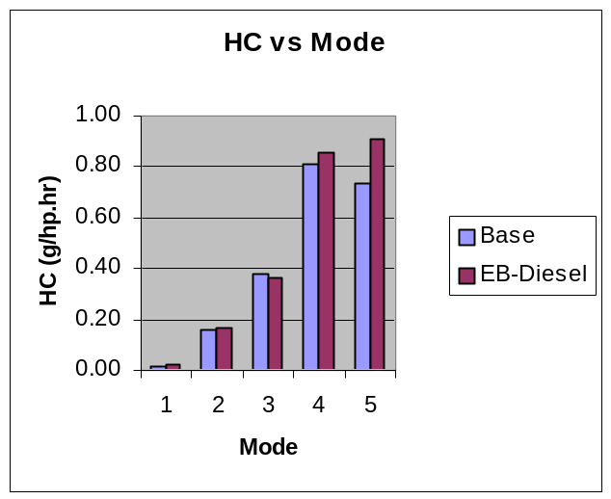

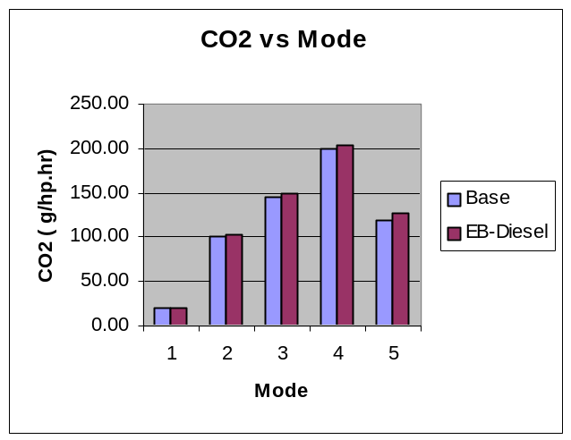

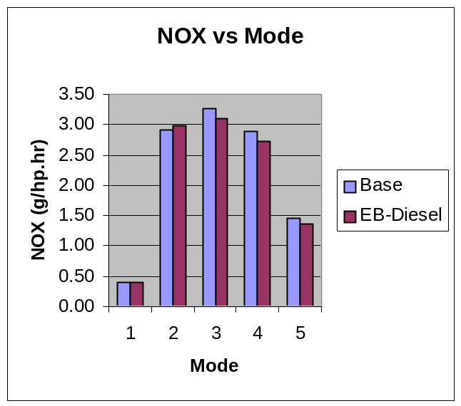

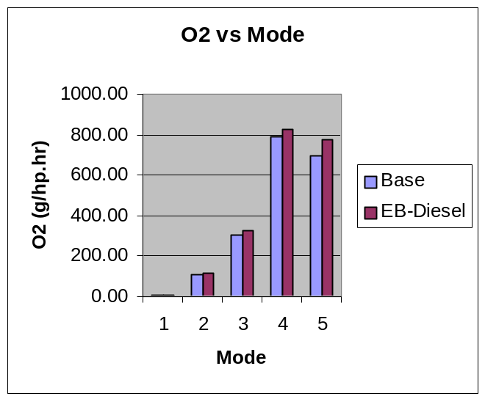

PARTICULATE EMISSIONS

The first fuel, Base #2 Diesel, was tested at five separate load levels coinciding with the ISO 8178 standards. Each test was run at one-minute intervals in order to get a consistent result. At all the load settings, the engine did not produce any measurable particulate emissions in each test sequence. With each sequence happening three times, there was no change in the opacity reading of zero.

The second fuel, the EB-Diesel, was then tested at these same conditions. The readings of zero opacity were once again found. This held true throughout all three sequences.

With the results from these first two sets of sequences, it was deemed unnecessary to conduct the final retesting of the base #2 Diesel.

ENGINE PERFORMANCE

When calculating the horsepower at the flywheel of the engine, the efficiency of both the generator and load bank at each mode were used. Information on efficiency of the generator came from Katolight, while the efficiency of the load bank was calculated by dividing actual wattage output by the numerical setting of the load bank. Table 9 has values used during calculations.

Table 9
EFFICIENCY

 | Load Bank % | Generator % | Overall %
Mode 1 | 0.94 | 0.61 | 0.5734
Mode 2 | 0.92 | 0.68 | 0.6256
Mode 3 | 0.92 | 0.77 | 0.7084
Mode 4 | 0.91 | 0.80 | 0.7280
Mode 5 | 0.93 | 0.77 | 0.7161

FUEL EFFICIENCY

A graph of the brake specific fuel consumption over the five modes is shown under Table 11. It is measured in pounds per horsepower hour. From Table 10 and 11 one can see that the Btu’s/hp*hr for the # 2 Diesel are higher than that of EB-Diesel by 31Btu’s/hp*hr at maximum load.

From the results about 3-8% more EB-Diesel fuel is needed to produce the same horsepower as # 2 Diesel. This is because EB-Diesel has 2% less Btu’s per gallon compared to #2 Diesel.

Table 10
BASE #2 DIESEL

 | Mode1 | Mode2 | Mode3 | Mode4 | Mode5
Voltage | 227.7 | 229.8 | 231.4 | 231.6 | 229.0
Current | 62.1 | 46.1 | 30.4 | 14.9 | 6.2
HP, load bank | 18.9 | 14.2 | 9.4 | 4.6 | 1.9
HP, Engine | 33.0 | 22.7 | 13.3 | 6.4 | 2.6
Air Press. | 28.9 | 28.9 | 28.9 | 28.9 | 28.9
Inlet Temp. | 110.3 | 108.6 | 103.2 | 98.1 | 95.3
RAD | 89.5 | 89.7 | 90.6 | 91.5 | 91.9
STP corr. HP | 36.9 | 25.3 | 14.7 | 7.0 | 2.9
Time (sec) | 160.0 | 160.0 | 160.0 | 160.0 | 160.0
Time (min) | 2.7 | 2.7 | 2.7 | 2.7 | 2.7
Fuel rate,g/m | 80.9 | 56.3 | 38.8 | 25.7 | 19.1
Fuel, g | 215.8 | 150.2 | 103.5 | 68.5 | 50.8
Fuel (lbs) | 0.48 | 0.33 | 0.23 | 0.15 | 0.11
BSFC | 0.29 | 0.29 | 0.35 | 0.49 | 0.88
Btu's/hp.hr | 5197 | 5274 | 6270 | 8756 | 15711

Table 11
EB-DIESEL

 | Mode 1 | Mode 2 | Mode 3 | Mode 4 | Mode 5
Voltage | 228.9 | 230.8 | 231.0 | 230.3 | 229.1
Current | 62.3 | 46.4 | 30.3 | 14.9 | 6.2
HP, load bank | 19.1 | 14.4 | 9.4 | 4.6 | 1.9
HP, Engine | 33.4 | 22.9 | 13.3 | 6.3 | 2.6
Air Press. | 28.9 | 28.9 | 28.9 | 28.9 | 28.9
Inlet Temp. | 108.2 | 108.7 | 103.1 | 96.7 | 95.7
RAD | 89.9 | 89.9 | 90.8 | 91.8 | 92.0
STP corr. HP | 37.1 | 25.5 | 14.6 | 6.9 | 2.9
Time (sec) | 160.0 | 160.0 | 160.0 | 160.0 | 160.0
Time (min) | 2.7 | 2.7 | 2.7 | 2.7 | 2.7
Fuel rate,g/m | 82.3 | 58.4 | 40.6 | 26.3 | 20.9
Fuel, g | 219.5 | 155.8 | 108.3 | 70.0 | 55.7
Fuel (lbs) | 0.48 | 0.34 | 0.24 | 0.15 | 0.12
BSFC | 0.29 | 0.30 | 0.37 | 0.51 | 0.96
Btu's/hp.hr | 5166 | 5329 | 6473.8 | 8912.1 | 16928

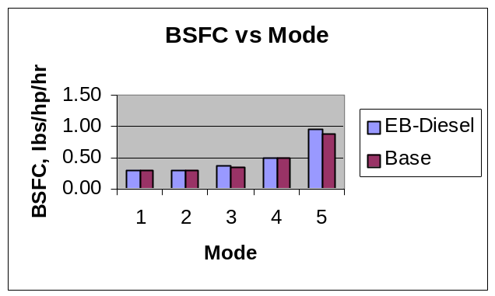

COST OF OPERATION

Table 12 contains the cost per gallon of the various fuels used in this project.

Table 12

Fuel | Cost/Gallon ($)
E95 | 1.50
BIO-DIESEL | 2.50
#2 DIESEL | 1.32
EB-DIESEL | 1.45
CETANE IMPROVER | 0.05
EB-DIESEL W/ ADDITIVE | 1.50

CALCULATIONS

5% Ethanol 5 * 1.5 / 100 = $0.075

10% Bio-Diesel 10 * 2.5 / 100 = $0.25

85% #2 Diesel 85 * 1.32 / 100 = $1.12

EB-Diesel 0.075 + 0.25 + 1.12 = $1.45

CONCLUSIONS

GASEOUS EMISSIONS

When comparing the gaseous emissions between the #2 Base Diesel fuel and the EB-Diesel, the hydrocarbons of the EB-Diesel were slightly higher. All the other gaseous emissions were very similar between the two fuels.

PARTICULATE EMISSION

There was no observed change in particulate matter between the two tested fuel. This is drawn from the fact there was no numerical change in the opacity between the settings of load on the ISO 8178 procedure that was followed.

FUEL EFFICIENCY

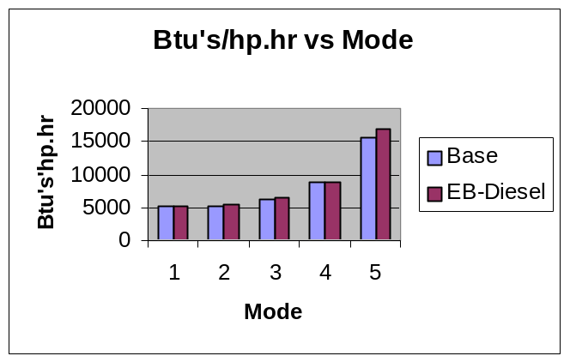

From the graph above, one can see that at Mode 1, which is the maximum load, the engine had about the same fuel efficiency running on both fuels. However, at partial loads the fuel efficiency of the EB-Diesel gradually surpassed that of #2 Diesel.

ENGINE PERFORMANCE

The power output by the engine was very similar between the two fuels tested. There was conflicting data between the engine tag and paper specs on what the maximum flywheel horsepower was. On the engine tag it was rated as 31 hp @ 1800rpm, on the paper specification sheet it was rated at 28.2 hp @1800rpm.
After all test data was collected and processed, a maximum horsepower of 32 hp @ 1800 rpm was measured.

RECOMMEDATIONS

The idea of using more Bio-Diesel is a good path to follow. The Bio-Diesel portion is able to reduce the emissions as the amount used is augmented. As the regulations of sulfur content lower, there needs to be something that will bring back the lubricity of the fuel. Bio-Diesel is able to add the lubricity and control the amount of carbon dioxide produced.

The EB-Diesel will be able to hold the premium fuel standard with the increase of Bio-Diesel. This happens with the characteristic of Bio-Diesel of being a cetane improver. The Bio-Diesel will counteract the lowering from Ethanol of the cetane number.

ADDITIVES

Additives that could be used are cetane improvers. The cetane number is a measure of ignition quality of a diesel fuel. The cetane number of an engine is calculated by using the procedure outlined in ASTM test D-613. A typical cetane number for #2 Diesel fuel is 42. Due to the mix of 5% ethanol in the EB-Diesel fuel blend, the cetane number would have been reduced. This number can be improved by using cetane improvers.

Common chemicals that are used in cetane improvers are Alkyl Nitrates. These chemicals readily break down to release oxygen, which helps in combustion. Depending on the amount of high versus low cetane components in the base fuel, typical alkyl nitrate additive treatments can increase cetane by about 3 to 5 numbers (1:1000 ratio). With high natural cetane premium base fuels (containing a high percentage of parafins), a 1:500 treatment ratio would increase cetane to a maximum of about 7 numbers.

Some of the cetane improvers currently on the market right now are the PFR 1347 by Baker Petrolite Additives, Texas, and DURALT by Everbest Products Inc., California.

An 80 oz. bottle of DURALT can treat 200 gallons of Diesel, which moves the cetane number up by 3-5 points.

SPONSORS/PARTICIPANTS

- Minnesota State University, Mankato
- Minnesota Corn Research and Promotion Council
- Minnesota Soybean Research and Promotion Council
- Katolight
- John Deere

Appendix A

Mixing Table for Blending Test Fuels

Sample # | Blend | Ethanol (ml) | Bio-Diesel (ml) | Diesel #1/#2 | Total
1 | 0E, 0B, 100D1 | 0 | 0 | 350 | 350
2 | 0E, 0B, 100D2 | 0 | 0 | 350 | 350
3 | 5E, 5B, 90D1 | 17.5 | 17.5 | 315 | 350
4 | 2E, 2B, 96D2 | 7 | 7 | 336 | 350
5 | 2E, 5B, 93D2 | 7 | 17.5 | 325.5 | 350
6 | 2E, 10B, 88D2 | 7 | 35 | 308 | 350
7 | 5E, 5B, 90D2 | 17.5 | 17.5 | 315 | 350
8 | 0E, 0B, 100D2 | 0 | 0 | 350 | 350
9 | 5E, 10B, 85D2 | 17.5 | 35 | 297.5 | 350
10 | 5E, 10B, 85D2 | 17.5 | 35 | 297.5 | 350
11 | 10E, 10B, 80D2 | 35 | 35 | 280 | 350
12 | 5E, 5B, 90D1 | 17.5 | 17.5 | 315 | 350
13 | 0E, 2B, 98D2 | 0 | 7 | 343 | 350
14 | 2E, 20B, 78D2 | 7 | 70 | 273 | 350
15 | 5E, 20B, 75D2 | 17.5 | 70 | 262.5 | 350
16 | 10E, 20B, 70D2 | 35 | 70 | 245 | 350
17 | 0E, 2B, 98D2 | 0 | 7 | 343 | 350
18 | 5E, 5B, 90D2 | 17.5 | 17.5 | 315 | 350
19 | 0E, 5B, 95D2 | 0 | 17.5 | 332.5 | 350
20 | 0E, 10B, 90D2 | 0 | 35 | 315 | 350
21 | 0E,20B, 80D2 | 0 | 70 | 280 | 350
22 | 100E,0B, 0D | 350 | 0 | 0 | 350
23 | 0E, 100B, 0D | 0 | 350 | 0 | 350
24 | 2E, 10B, 88D2 | 7 | 35 | 308 | 350

Appendix B

Gaseous Emissions Test Setup Procedure

- Check engine fluid levels
_____ Oil Crankcase Level
_____ Fuel Canister Full/Return Lines and Main Fuel Placed Correctly
- Check System Ground is connected
- Battery Connected
- All data connections in place and functioning
_____ Bench Connections
_____ Scale connector
_____ Heated hose line
_____ Air Thermocouple (Air Horn)
_____ Air Flow (Air Horn)
_____ RPM Sensor
_____ Heated Filter Box on C-Channel Switch ON
_____FLUKE Connections
_____ Fluke to Computer
_____ Voltage
_____ Current
_____ Oil Temperature (K-yellow)
_____ Exhaust temp (J-black)
- Power Strip on C-Channel Switch ON
- Turn Diesel Engine ON (Idle 10 minutes)
- Turn on Load Bank and FAN SWITCH
- Set Load Capacity Switches
- Turn on Generator
- Run engine 1 minute
- Start Logging
_____ Fluke
_____ Bench
12) Run____5_ minutes
13) Stop logging
_____ Fluke
_____ Bench
14) Store Data
15) Leave Engine Running, Turn Generator OFF
16) Turn Load Bank to next Load Setting, Turn Generator ON
- Run engine 1 minute
- Start Logging
_____ Fluke
_____ Bench
- Run __5____ minutes
- Stop Logging
_____ Fluke
_____ Bench
- Store Data
- Leave Engine Running
- Repeat Steps 10-16
- Switch Fuels After All Load settings done 3 times
- Fill New Fuel Filter with New Mixture
- Replace Old Filter
- Run Return Lines into separate container
- Run Engine 5 minutes
- Take Sample of Return line Directly, Not From Container
- Measure Specific Gravity
- If Specific Gravity is of New Fuel
_____ Begin From Step 1
_____ IF NOT, Run Engine another 5 minutes and Test Fuel again
- Condition 4 minutes each load setting (20 minutes total)
- Continue Testing from Steps 10-16
- Switch Fuels after each load setting is completed 3 times
- Follow Steps for switching 24-31
- Continue Testing steps 10-16
- Turn off Generator
- Stop Engine
- Collect All Data Stored

Appendix C

Opacity Test Setup Procedure

- Check engine fluid levels
- _____ Oil Crankcase Level
- _____ Fuel Canister Full/Return Lines and Main Fuel Placed Correctly
- Check System Ground is connected
- Battery Connected
- All data connections in place and functioning
- _____ Opacity meter head unit
- _____ Opacity Printer
- _____ Opacity Power Cord
- _____ Bench Connections
    - _____ Air Thermocouple (Air Horn)
    - _____ Air Flow (Air Horn)
    - _____ RPM Sensor
- _____ FLUKE Connections
    - _____ Fluke to Computer
    - _____ Voltage
    - _____ Current
    - _____ Oil Temperature
- Power Strip on C-Channel Switch ON
- Turn on Diesel Engine On Idle 10 minutes
- Turn on Load Bank ON and FAN SWITCH
- Set Load Capacity Switches
- Turn on Generator
- Set RPM to 1800
- Run engine 1 minute
- Start Camera
- Start logging
- _____ STOP WATCH
- _____ Fluke
- _____ Bench
- _____ Opacity
- Run___1__ minutes
- Stop logging
- _____ Fluke
- _____ Bench
- _____ Opacity
- 16) Store Data
- 17) Leave Engine Running, Turn GENERATOR OFF
- 18) Turn Load Bank to next Load Setting, TURN GENERATOR ON
- Run engine 1 minute
- Start Logging
- _____ Fluke
- _____ Bench
- _____ Opacity
- Run __1____ minutes
- Stop Logging
- _____ Fluke
- _____ Bench
- _____ Opacity
- Store Data
- Leave Engine Running
- Repeat Steps 10-16
- Clean and Zero Opacity Meter after each sequence of load settings
- Switch Fuels After All Load settings done 3 times
- Fill New Fuel Filter with New Mixture
- Replace Old Filter
- Run Return Lines into separate container
- Run Engine 15 minutes
- Take Sample of Return line Directly, Not Container
- Measure Specific Gravity
- If Specific Gravity is of New Fuel
- _____ Begin From Step 1
- _____ IF NOT, Run Engine another 5 minutes and Test Fuel again
- Condition at 4 minutes each load (20 minutes total) after fuel change
- Continue Testing from Steps 10-16
- Switch Fuels after each load setting is completed 3 times
- Follow Steps for switching 25-32
- Continue Testing steps 10-16
- Turn off Generator
- Stop Engine
- Collect All Data Stored

Appendix E

All readings in the following tables are in g/bhp*hr.

#2 Diesel Base 1
Mode #1 | Test 1 | Test 2 | Test 3 | Average | Std. Dev. | 95%(+/-)
HC | 0.030 | 0.023 | 0.026 | 0.026 | 0.004 | 0.009
CO | 0.000 | 0.000 | 0.000 | 0.000 | 0.000 | 0.000
CO2 | 19.499 | 19.661 | 20.002 | 19.721 | 0.257 | 0.638
NOX | 0.388 | 0.363 | 0.416 | 0.389 | 0.027 | 0.066
O2 | 9.459 | 8.460 | 10.183 | 9.367 | 0.865 | 2.149

#2 Diesel Base 1
Mode #2 | Test 1 | Test 2 | Test 3 | Average | Std. Dev. | 95%(+/-)
HC | 0.146 | 0.165 | 0.158 | 0.156 | 0.010 | 0.024
CO | 0.000 | 0.000 | 0.000 | 0.000 | 0.000 | 0.000
CO2 | 99.462 | 102.967 | 102.298 | 101.576 | 1.861 | 4.623
NOX | 2.822 | 3.002 | 2.923 | 2.916 | 0.090 | 0.224
O2 | 110.982 | 112.844 | 111.868 | 111.898 | 0.931 | 2.314

#2 Diesel Base 1
Mode #3 | Test 1 | Test 2 | Test 3 | Average | Std. Dev. | 95%(+/-)
HC | 0.356 | 0.385 | 0.387 | 0.376 | 0.017 | 0.043
CO | 0.000 | 0.000 | 0.000 | 0.000 | 0.000 | 0.000
CO2 | 137.130 | 147.850 | 148.391 | 144.457 | 6.351 | 15.778
NOX | 3.053 | 3.399 | 3.368 | 3.273 | 0.191 | 0.476
O2 | 293.091 | 307.021 | 312.912 | 304.341 | 10.179 | 25.287

#2 Diesel Base 1
Mode #4 | Test 1 | Test 2 | Test 3 | Average | Std. Dev. | 95%(+/-)
HC | 0.802 | 0.814 | 0.826 | 0.814 | 0.012 | 0.030
CO | 0.000 | 0.000 | 0.000 | 0.000 | 0.000 | 0.000
CO2 | 203.615 | 197.295 | 199.990 | 200.300 | 3.171 | 7.879
NOX | 2.884 | 2.888 | 2.927 | 2.900 | 0.024 | 0.059
O2 | 795.251 | 780.315 | 796.217 | 790.594 | 8.915 | 22.149

#2 Diesel Base 1
Mode #5 | Test 1 | Test 2 | Test 3 | Average | Std. Dev. | 95%(+/-)
HC | 0.704 | 0.779 | 0.727 | 0.737 | 0.038 | 0.095
CO | 0.000 | 0.000 | 0.000 | 0.000 | 0.000 | 0.000
CO2 | 114.842 | 123.889 | 117.991 | 118.907 | 4.593 | 11.410
NOX | 1.380 | 1.548 | 1.464 | 1.464 | 0.084 | 0.209
O2 | 668.114 | 722.902 | 693.884 | 694.967 | 27.410 | 68.096

EB-Diesel
Mode #1 | Test 1 | Test 2 | Test 3 | Average | Std. Dev. | 95%(+/-)
HC | 0.027 | 0.025 | 0.025 | 0.026 | 0.001 | 0.003
CO | 0.000 | 0.000 | 0.000 | 0.000 | 0.000 | 0.000
CO2 | 19.826 | 19.747 | 19.780 | 19.784 | 0.040 | 0.099
NOX | 0.401 | 0.383 | 0.380 | 0.388 | 0.011 | 0.028
O2 | 8.928 | 8.400 | 8.511 | 8.613 | 0.278 | 0.692

EB-Diesel
Mode #2 | Test 1 | Test 2 | Test 3 | Average | Std. Dev. | 95%(+/-)
HC | 0.174 | 0.161 | 0.154 | 0.163 | 0.010 | 0.025
CO | 0.000 | 0.000 | 0.000 | 0.000 | 0.000 | 0.000
CO2 | 104.186 | 103.867 | 100.257 | 102.770 | 2.182 | 5.421
NOX | 3.097 | 3.009 | 2.869 | 2.992 | 0.115 | 0.286
O2 | 114.219 | 115.314 | 112.171 | 113.901 | 1.595 | 3.964

EB-Diesel
Mode #3 | Test 1 | Test 2 | Test 3 | Average | Std. Dev. | 95%(+/-)
HC | 0.407 | 0.340 | 0.343 | 0.363 | 0.038 | 0.094
CO | 0.000 | 0.000 | 0.000 | 0.000 | 0.000 | 0.000
CO2 | 147.722 | 152.831 | 148.656 | 149.736 | 2.720 | 6.759
NOX | 3.094 | 3.177 | 3.012 | 3.094 | 0.083 | 0.205
O2 | 321.020 | 323.810 | 324.597 | 323.142 | 1.880 | 4.670

EB-Diesel
Mode #4 | Test 1 | Test 2 | Test 3 | Average | Std. Dev. | 95%(+/-)
HC | 0.859 | 0.879 | 0.827 | 0.855 | 0.026 | 0.065
CO | 0.000 | 0.000 | 0.000 | 0.000 | 0.000 | 0.000
CO2 | 204.183 | 210.072 | 198.440 | 204.232 | 5.816 | 14.449
NOX | 2.779 | 2.773 | 2.599 | 2.717 | 0.102 | 0.254
O2 | 817.558 | 847.825 | 805.280 | 823.554 | 21.897 | 54.400

EB-Diesel
Mode #5 | Test 1 | Test 2 | Test 3 | Average | Std. Dev. | 95%(+/-)
HC | 0.893 | 0.934 | 0.905 | 0.911 | 0.021 | 0.052
CO | 0.000 | 0.000 | 0.000 | 0.000 | 0.000 | 0.000
CO2 | 126.095 | 130.806 | 126.090 | 127.664 | 2.721 | 6.761
NOX | 1.362 | 1.392 | 1.345 | 1.366 | 0.024 | 0.059
O2 | 737.266 | 774.255 | 805.280 | 772.267 | 34.051 | 84.593

