Small Wind Farm Research at
MSU

22 Nov 11

Dr. Vincent Winstead

Graduate Student: Ms. Priti Sood

Topics

• Applied Small Wind Project

• Wind Farm Modeling

• Simulation Efforts

• On-going Studies

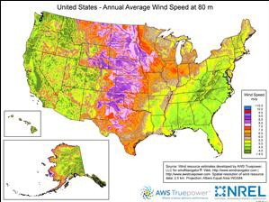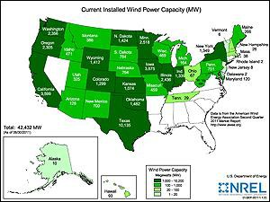Motivation

From: www.windpoweringamerica.gov

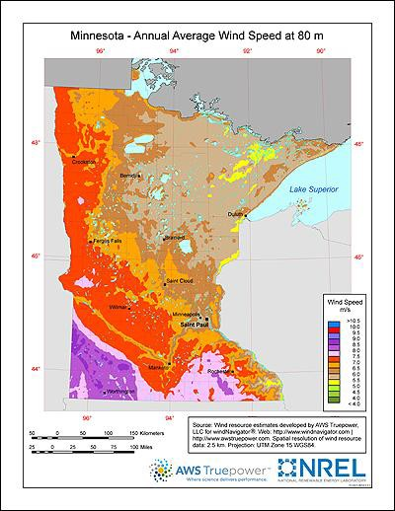Motivation

• 2025 Energy Initiative
– 25% electrical energy via
renewables by 2025
– How to get there?
• Minnesota is number 4 in installed wind in the U.S.
• What about residential
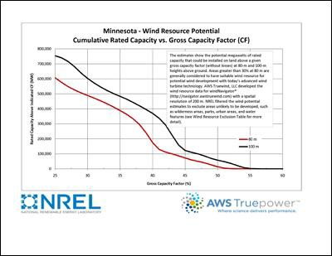installations?

From: www.windpoweringamerica.gov From: www.windpoweringamerica.gov

Project Scope

• Small (Residential Scale) Wind Installations
using commercially available systems

• Questions to answer: What are…

– Costs associated with purchase, installation

– Electrical code issues

– Maintenance requirements

– Performance capability vs. manufacturer data

• Can the typically consumer benefit?

Self-Imposed Constraints

• Roughly 2-3kW rated output

• U.S. manufacturer or distributor

• Some VAWTs (Vertical Axis) and some HAWTs
(Horizontal Axis)

PacWind – Delta I
Decision Process

Southwest Windpower – Skystream 3.7
Urban Green Energy - SAWT 3kW
Southwest Windpower – Whisper 500

WindMax 2kW (similar)
Southwest Windpower – Skystream 3.7
Urban Green Energy - SAWT 3kW
Abundant Renewable Energy – ARE 110

- PacWind becomes WePOWER
- WePOWER also markets SAWT turbines
Helixwind S322
Southwest Windpower – Skystream 3.7
Urban Green Energy - SAWT 3kW
Abundant Renewable Energy – ARE 110

- Abundant Renewable Energy becomes XZERES Wind

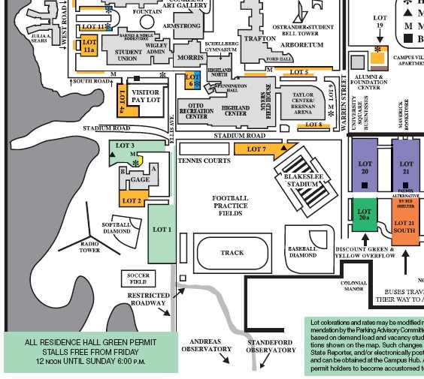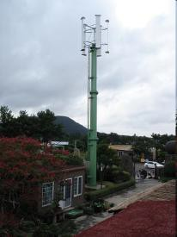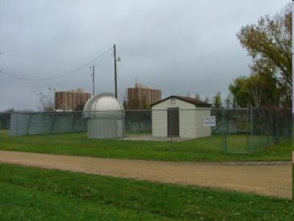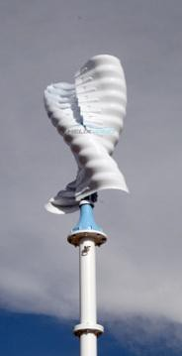Specifications

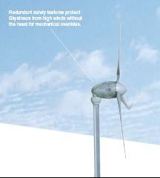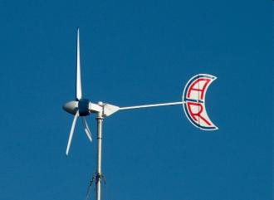• SAWT 3kW – 3.3kW
rated
• ARE 110 – 2.5kW rated
• Skystream 3.7 – 1.9kW
rated (later 2.4kW)
• Helixwind S322 – 2.5kW

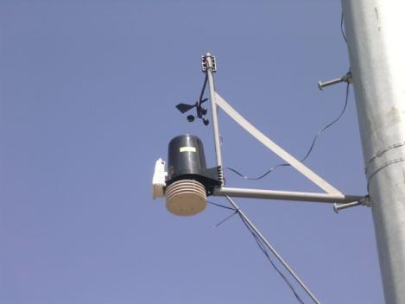

• Battery charging
– 48VDC pack
– Internal or
external rectifier
– Charge controller
– Grid isolated
– Diversion load
Configuration

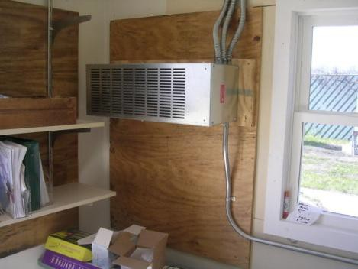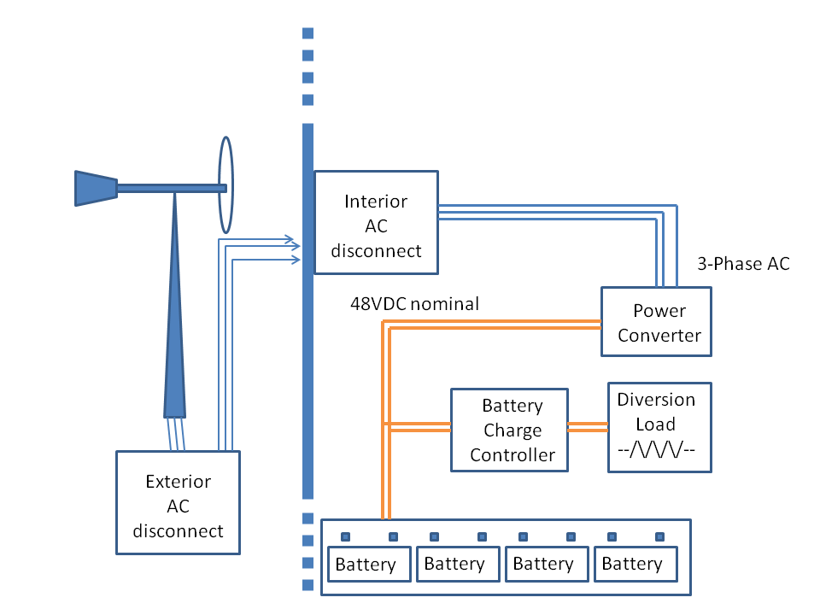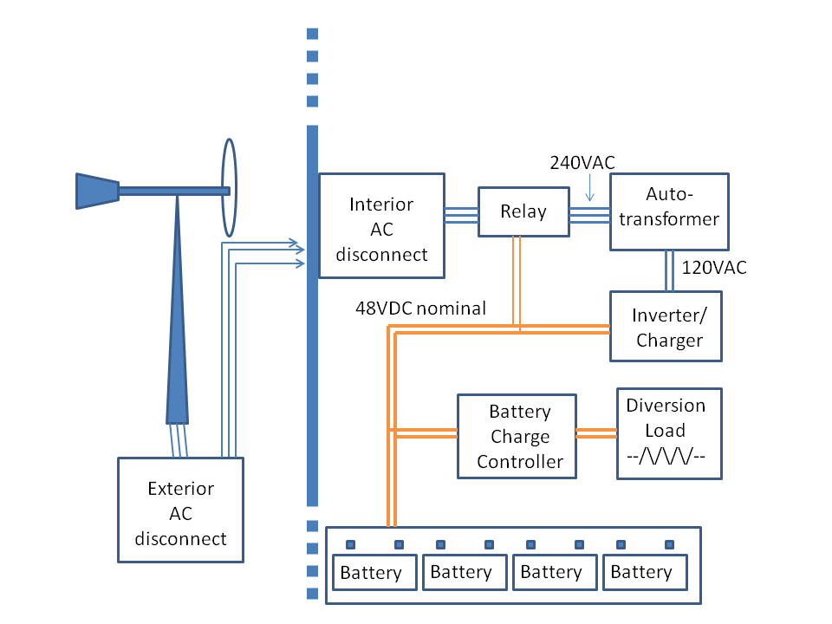

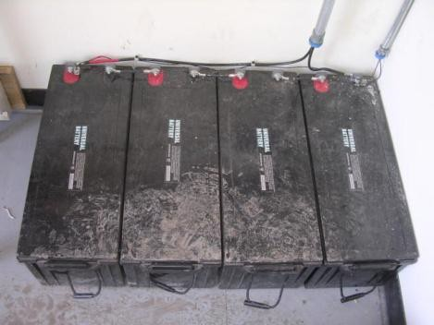
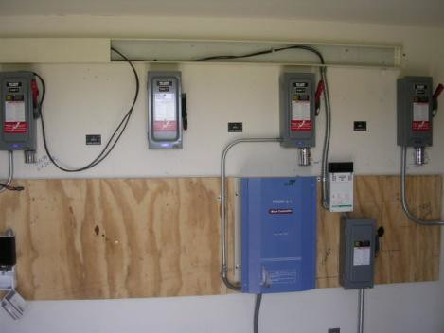

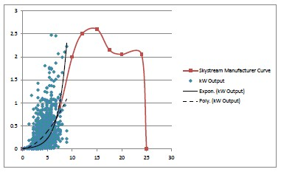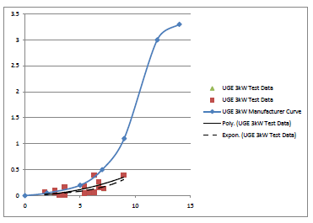

Southwest Windpower Skystream 3.7

18% average MN
household demand

UGE SAWT 3kW

3.3% average MN
household demand
Results

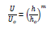Power law

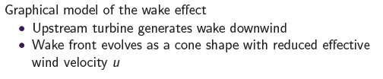Modeling

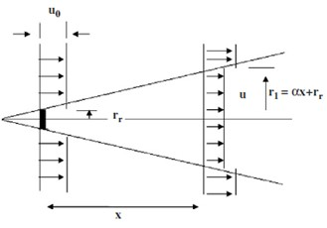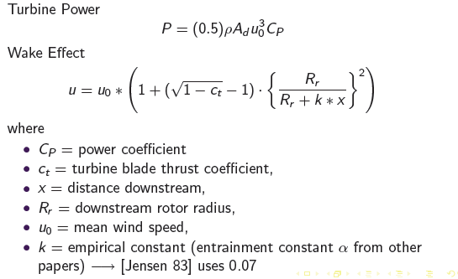

• Modeling efforts based on manufacturer power curve,
tower height, wind direction/speed and wake effect

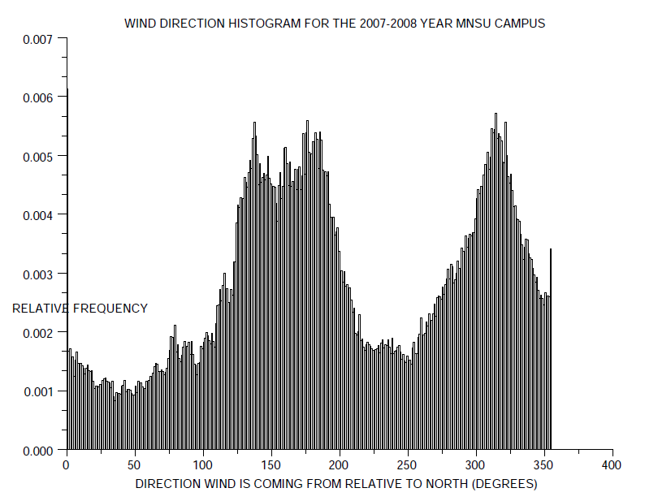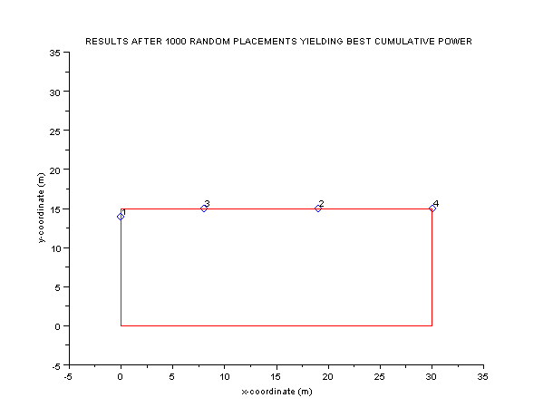Simulations

• Results of wind sensor data and Monte Carlo based turbine placement

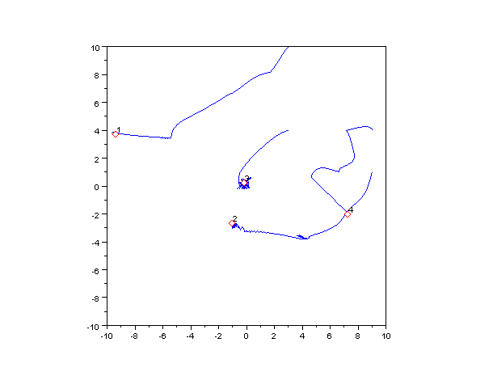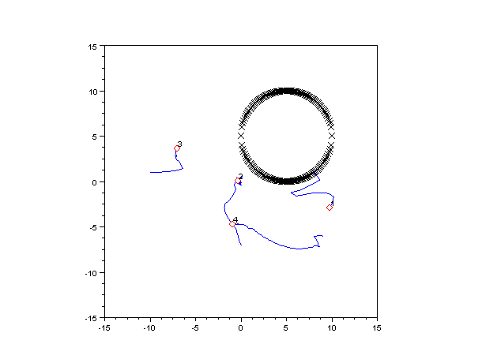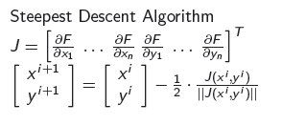Simulations

• Steepest descent algorithm driven by multi-criteria cost function

Next Steps

• Applied projects

– Helixwind S322 power converter

– Advanced power data acquisition (smart grid
capable)

• Simulation studies

– Convergence proofs

– Terrain/obstacle incorporation

Questions?

